Issues
- Put the section title Issues.

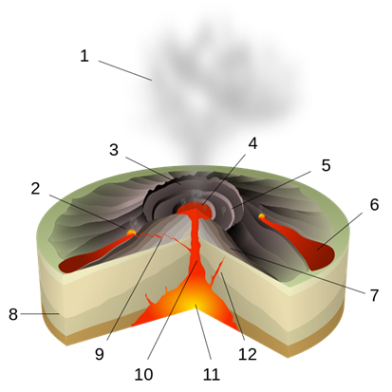

- Draw a labelled sketch of a shield volcano. Only label:
3. CRATER
6. LAVA FLOW
7. LAYERS OF ASH &
LAVA
11. MAGMA CHAMBER

- At which type of plate boundary and at which other type of location are shield volcanoes found?

- What is the main feature of the magma that makes up a shield volcano?

- Draw a labelled sketch of composite cone volcano. Only label:
1. ASH PLUME
2. MAGMA CONDUIT
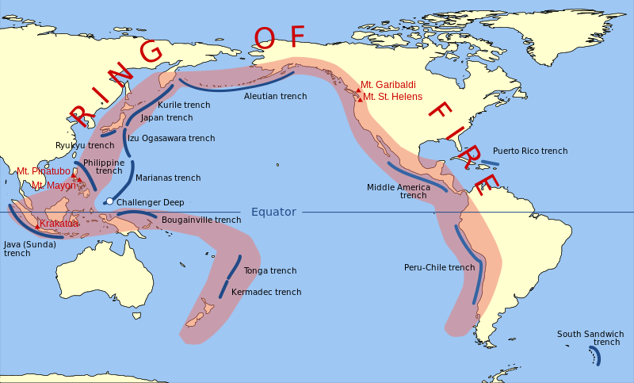
3. VOLCANIC ASH FALL
4. LAYERS OF ASH & LAVA
6. MAGMA CHAMBER
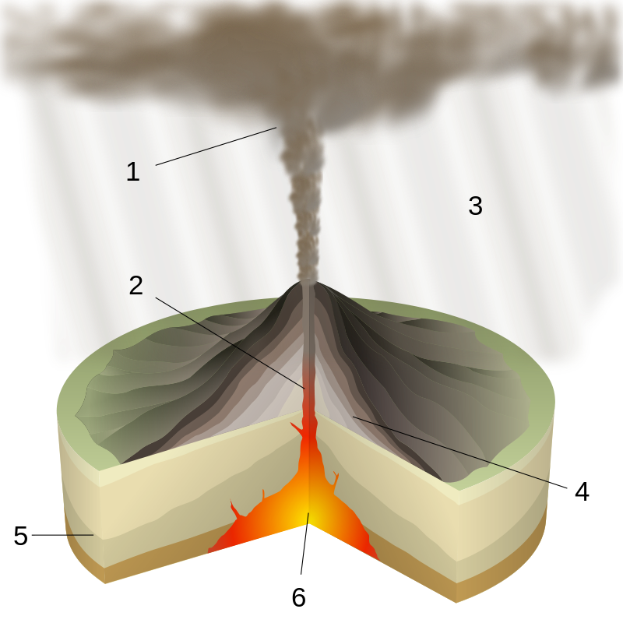
- At which type of plate boundary are composite cone volcanoes found?

- What are the main features of the magma that makes up a composite cone volcano?

- Draw up a table to show the differences and similarities between shield and composite cone volcanoes.

Similarities | Differences

- Where is the ‘Ring of Fire’?

- What is the ring of fire?

Decisions
- Put the section title Decisions and imagine that you are in charge of a town or city close to either Mount Vesuvius or Krakatau. 3 million people live in the danger zone of Vesuvius and over 20 million in the danger zone from Krakatau.

- Describe under the sub-heading Prediction list four ways in which you could predict the volcano was about to erupt.
Prediction
1
2
3
4

- Describe under the sub-heading Prevention list four ways in which you could prevent hazards during an eruption.
Prevention
1
2
3
4

- Now draw up a ranked (most important first) list of planned drills for everyone to practice under the heading Preparation. Start with evacuation as the most important.
Preparation
1 Evacuation
2
3
4

