Introduction
- Put the section title Introduction.
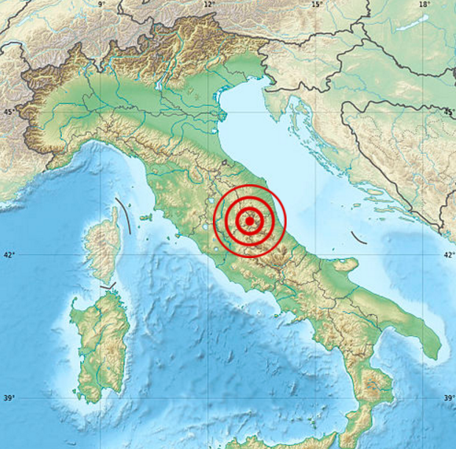
- What are the five most important facts about the August 2016 Italy Earthquake.

- Cut out and use this map to describe the location of the earthquake.

- Draw two graphs to show how many people were killed and injured and the countries that they came from.

Nationalities of Victims
Nationality | Dead | Injured
Italy | 276 | 376
Romania | 11 | 6
United Kingdom | 3 | 2
United States | 1 | 2
Albania | 1 | 7
El Salvador | 1 | 1
Canada | 1 | 1
Spain | 1
Macedonia |  | 1

- Cut out and use this map to describe the location of Italy within the belts of earthquakes around the Earth.
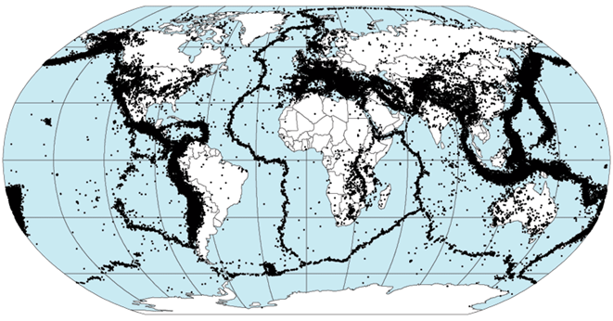

Background
- Put the section title Background.
- Put a sub-heading The Plate Tectonic Model.

- Cut out and use the following two maps to help you to describe the location of Italy relative to Tectonic Plates.
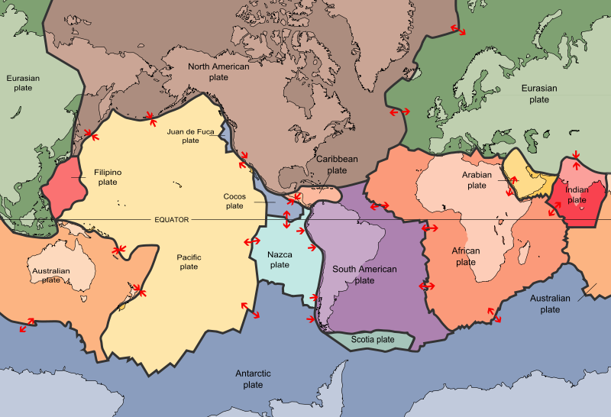

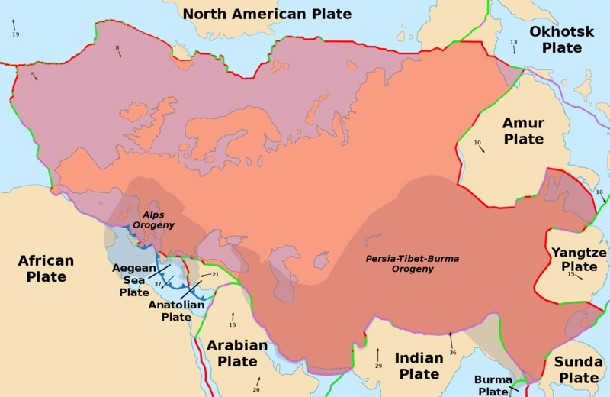

- Cut out and use the following diagram to help you describe the structure of the Earth.
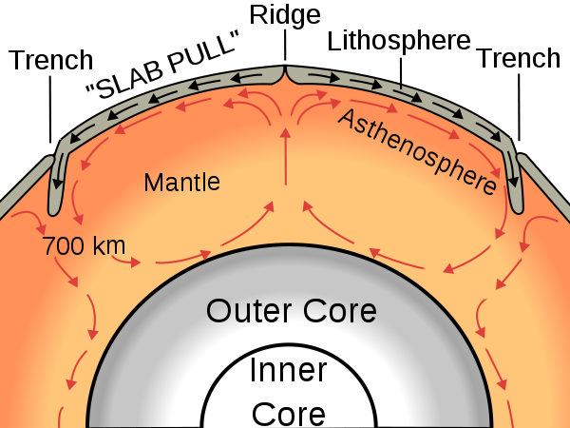

- Explain that the Tectonic Plates move on convection currents in the mantle.

- Cut out and use the following diagrams to explain the main types of plate boundaries:
Divergent Boundary

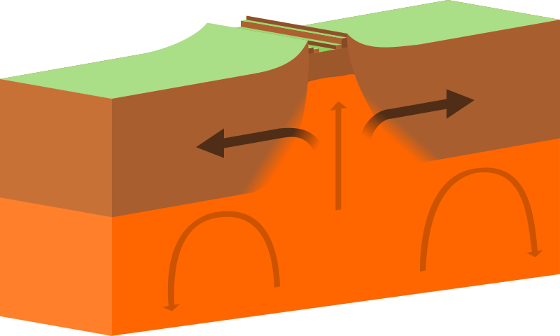

Convergent Boundary

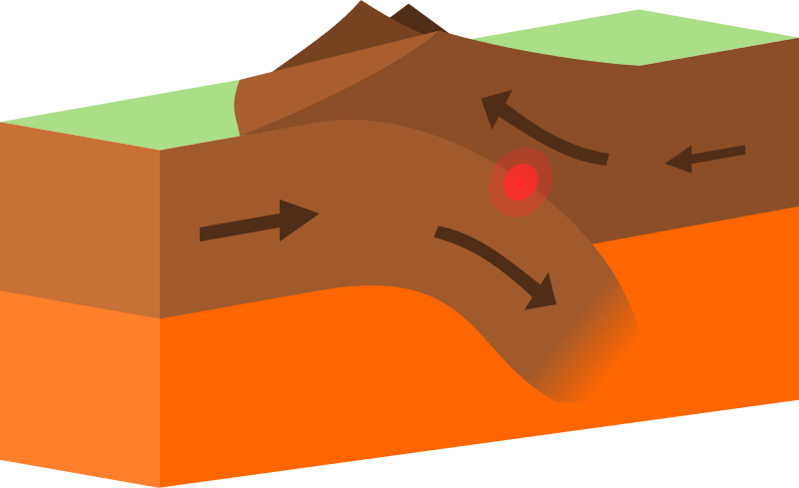

Conservative Boundary

