What Will We Do About Storms?
Decision Making Exercise

Imagine you have been appointed as a reporter for the BBC.

You will be asked to write a brief report for the Newsround programme outlining why storms in the UK are now being named and how the storms of winter 2015-2016 have been record breaking.

You will also need to give advice for younger people about what they should do to prepare for storms and floods.

- Give a background summary of why storms are being named by the Met Office.

- Describe and explain how storms affect people:
  - Wind
  - Precipitation

- Review data to describe how winter 2015-2016 has been a record breaking storm season.

  - Explain how Wales has been affected compared to the rest of the UK.

- Your Decision:
  - What should young people do before storms and floods
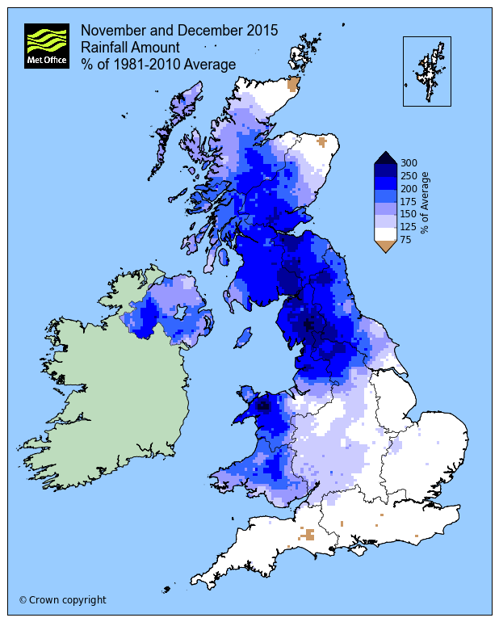
  - What should young people do after storms and floods
…………………………………………………..

- Use the Section heading Introduction before answering the following questions in the form of a paragraph (not separately):
  - What is the Met Office?
  - Why are storms being named?
  - Is climate change affecting storms?
    - By how much?

- Give four different examples of weather records that have been broken during winter 2015-2016.
a
b
c
d

- Give a brief outline of the storms to affect the UK from November 2015 – February 2016; include:
  - Storm name
  - Areas most affected
  - Wind speeds
  - Flooding caused
  - Power cuts
  - Loss of life
  - Transport impacts
  - Social impacts such as school closures
  - Estimated costs to fix

- Why might it be fair to say that Wales has been lucky with the storms that have hit the UK during winter 2015-2016?

- Can you think of any places in Wales that might argue that it is not fair to say that Wales has been lucky?
  - Where might they live?
  - Why might they argue that Wales has not been lucky?

- Draw a graph to represent the following information:

 | mm
Average Height of Man in UK | 1753
Average Height of UK boy aged six | 1170
48 Hour rainfall record Thirlmere, Cumbria 5/6th Dec. 2015 | 405
24 Hour rainfall record Honister Pass, Cumbria 5th Dec. 2015 | 341.4

- Complete these activities from the online resource to analyse maps 1 & 2 and Graphs 1 & 2 from the Met Office Website.

Use your literacy and numeracy skills to write a description of both of these maps and both graphs.

For each try to answer each question as part of your description.

Map 1
- Overall what is it showing?
- Which places have the highest values (numbers)?
- Are any of the places with the highest values in Wales? Where?

Map 2
- Overall what is it showing?
- Which 3 places have the highest values (numbers)?
  - Where are they?
  - Where are they?

- Are any of the places with the highest values in Wales?
  - Where?

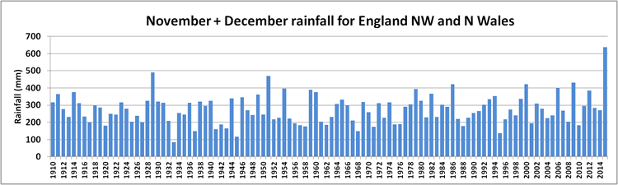
Graph 1
- Overall what is it showing?
- Which years have the highest values (numbers)?
- Which years have the lowest values (numbers)?
- Estimate (or work it out fully) a mean or average value.
- Roughly estimate how much bigger 2015 is compared to your estimate; choose from:
  - Times 1
  - Times 1.5
  - Times 2
  - Times 2.5
  - Times 3
  - Times 3.5
  - Times 4

Graph 2
- Overall what is the graph showing?
- Where is Shap?
- Where is Capel Curig?
- Compare the rainfall for both locations in November and December.

- Northern England has suffered severe flooding this winter; how does the amount of rainfall it received compare with Northern Wales?

- Why has the direction of the storms been so important for Wales this winter?
  - Where have most of the storms travelled to/through?

- Check that your answers have covered all of the points (except the last one) in the big picture task from the start of this sheet.

Imagine you have been appointed as a reporter for the BBC.

You will be asked to write a brief report for the Newsround programme outlining why storms in the UK are now being named and how the storms of winter 2015-2016 have been record breaking.

You will also need to give advice for younger people about what they should do to prepare for storms and floods.

- Give a background summary of why storms are being named by the Met Office.

- Describe and explain how storms affect people:
  - Wind
  - Precipitation

- Review data to describe how winter 2015-2016 has been a record breaking storm season.
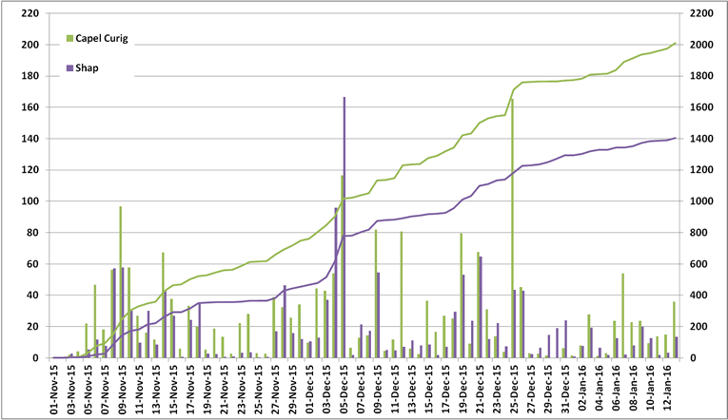
  - Explain how Wales has been affected compared to the rest of the UK.

- Your Advice:
  - What should young people do before storms and floods
  - What should young people do after storms and floods

- Complete the last task in two paragraphs of your own composition:

Your Advice

  - What should young people do before storms and floods
  - What should young people do after storms and floods

