What Will We Do About Climate Change?
Decision Making Exercise

Imagine you have been appointed as a negotiator for Wales at COP21 the Paris Climate Change Conference.

You will be asked to write a brief report outlining the issues affecting Wales as an example of a developed country and also other countries at a range of development along with recommendations of what we should do in Wales to help fight climate change:

- Give a background summary of issues related to climate change.

- Explain the consequences of climate change:
  - Temperature changes
  - Sea level changes
  - Drought

- Explain the main causes of anthropogenic climate change:
  - Emissions
  - Sinks

- Explain the options for fighting climate change:
  - Adaptation
    - Technology Transfer
  - Mitigation

- Your Decision:
  - Say what you think we should be doing in Wales
  - Justify why you think this is the best.
…………………………………………………..

- Use the Section heading Introduction before answering the following questions in the form of a paragraph (not separately):

  - What is weather?
  - What is climate?
  - What is anthropogenic climate change?

- What is the ‘Loss & Damage’ concept? Explain why this quotation from the agreement was included.

“Agreement does not involve or provide a basis for any liability or compensation”.

- Use this quote from the agreement to help you explain why it was so important that all countries agreed the new deal.

“Recognizing that climate change represents an urgent and potentially irreversible threat to human societies and the planet and thus requires the widest possible cooperation by all countries, and their participation in an effective and appropriate international response, with a view to accelerating the reduction of global greenhouse gas emissions”

- Use this quote from the IPPC to help you explain how an expected sea level increase of 0.5 metres would affect how frequent sever sea level events would be.

“A central estimate of 0.47m increase is projected by 2081-2100, relative to the 1986-2005 baseline. An increase of 0.5m is estimated to result in 10-fold to 100-fold increase in the frequency of sea level extremes (relative to present day) in northern Europe by the end of the century. This would mean a coastal flooding event that has a return period of 100 years at present will potentially occur on average between every year and every ten years by 2100.”

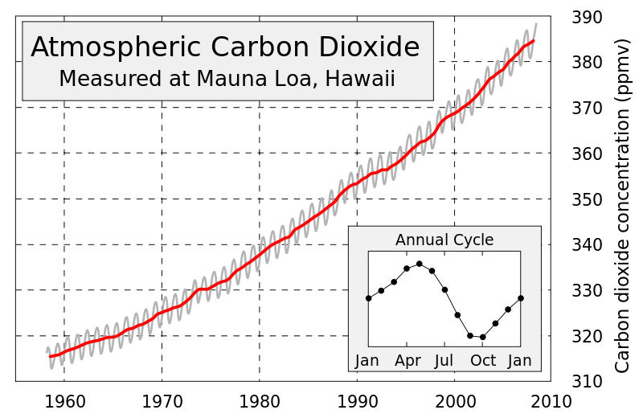
- Describe what this graph is showing you and explain how it could affect you in Wales.

- Explain how your activities are increasing the amount of Carbon Dioxide in the atmosphere.

- What is meant by the concept of ‘Transparency’ and why is it important.

 | % of global emissions | Population in December 2015 (Global Pop. = 7,387,943,081)
China | 24% | 1,367,485,388
USA | 12% | 321,368,864
EU | 9% | 507,000,000
Brazil | 6% | 204,259,812
India | 6% | 1,251,695,584
Russia | 5% | 142,423,773
Japan | 3% | 126,919,659
Canada | 2% | 35,099,836
D.R. Congo | 1.5% | 79,375,136
Indonesia | 1.5% | 255,993,674
- Use information from the table to create two graphs to show:
  - The % of global greenhouse gas emissions from each country.
  - The size of the population of each country.

- Use your numeracy skills to:
- Estimate whether emissions for different countries are in line with their population sizes.
- Compare emissions against population for:
  - China and India
  - USA and the EU.

- Using the online resource or this thumbnail image compare changes in emissions between 1990 and 2012 for a range of:
  - Developed countries
  - Developing countries
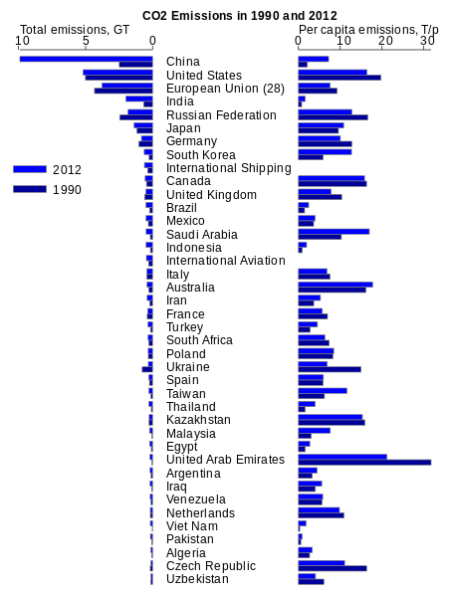
- Put the section heading Options.

- Using examples to help you explain the following concepts:

  - Technology Transfer
  - Adaptation
  - Mitigation

- Which countries will need to pay for this and why?

- How much money each year has been decided to start with?

- For Carbon Dioxide and Methane explain the following concepts:

  - Emissions

  - Sinks

- Using example to help you explain why some countries are more vulnerable to the consequences of climate change. Think about:

  - Levels of development

  - Physical characteristics

- Is temperature increasing at the same level everywhere on the planet?

- Why might some places such as the UK actually get cooler as a result of climate change?

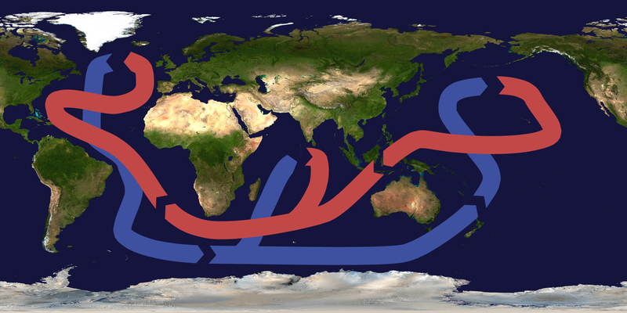
- Explain two reasons why sea levels might increase.

  - ?

  - ?

- Explain three reasons why storms might become more of a problem in the future.

  - ?

  - ?

  - ?

- Describe areas of the world where drought is a serious risk for the future.

- How might drought in these areas directly affect you in Wales

- Put the section heading Decision.

- Try to explain how we could approach the concept of adaptation here in Wales. Think about the following questions from the online resource:

  - Is it wise to continue to keep constructing new buildings on flat land next on coastlines and along the floors of river valleys?

  - Can farmers change the crops that they grow?

  - Can we reduce our use of water so that more is available if there is a drought?

  - Can we introduce new species to replace those that will struggle in our new climates?

  - How can we improve the way in which we respond to a greater frequency of severe storms?

- Try to explain how we could approach the concept of mitigation here in Wales. Think about the following questions from the online resource:

- What can we do to reduce the impacts of the consequences such as by accessing more water from underground or building new reservoirs to cope with droughts?

- What can we do if crops fail and there is a food shortage?

- Can we build flood defences to protect against sea level change and increased storms frequency and severity?

- What kinds of things can we do here in Wales to reduce our emissions? Think about these questions from the online resource:

- How can we reduce the fossil fuels that we burn to heat our homes or travel from place to place?

- What can we do with our waste?

- How can we protect or increase sinks of greenhouse gasses?

- Check that your answers have covered all of the points (except the last one) in the big picture task from the start of this sheet.

Imagine you have been appointed as a negotiator for Wales at COP21 the Paris Climate Change Conference.

You will be asked to write a brief report outlining the issues affecting Wales as an example of a developed country and also other countries at a range of development along with recommendations of what we should do in Wales to help fight climate change:

- Give a background summary of issues related to climate change.

- Explain the consequences of climate change:
  - Temperature changes
  - Sea level changes
  - Drought

- Explain the main causes of anthropogenic climate change:
  - Emissions
  - Sinks

- Explain the options for fighting climate change:
  - Adaptation
    - Technology Transfer
  - Mitigation

- Your Decision:
  - Say what you think we should be doing in Wales
  - Justify why you think this is the best.

- Complete the last task in two paragraphs of your own composition:

Your Decision

  - Say what you think we should be doing in Wales

  - Justify why you think this is the best.

