What Will We Do About Climate Change?
Decision Making Exercise

Imagine you have been appointed as a negotiator for Wales at COP21 the Paris Climate Change Conference.
You will be asked to write a brief report outlining the issues affecting Wales as an example of a developed country and also other countries at a range of development along with recommendations of what we should do in Wales to help fight climate change:

- Give a background summary of issues related to climate change.

- Explain the consequences of climate change:
  - Temperature changes
  - Sea level changes
  - Drought

- Explain the main causes of anthropogenic climate change:
  - Emissions
  - Sinks

- Explain the options for fighting climate change:
  - Adaptation
    - Technology Transfer
  - Mitigation

- Your Decision:
  - Say what you think we should be doing in Wales
  - Justify why you think this is the best.
…………………………………………………..
- Use the Section heading Introduction before answering the following questions in the form of a paragraph (not separately):

  - What is weather?
  - What is climate?
  - What is climate change?

- Use this quote from the agreement to help you explain why it was so important that all countries agreed the new deal.

“Recognizing that climate change represents an urgent and potentially irreversible threat to human societies and the planet and thus requires the widest possible cooperation by all countries, and their participation in an effective and appropriate international response, with a view to accelerating the reduction of global greenhouse gas emissions”

- Describe what this graph is showing you by answering these questions:

  - What was the Carbon Dioxide in 1960?
  - What was the Carbon Dioxide in 2008?
  - By how much has the Carbon Dioxide level changed?
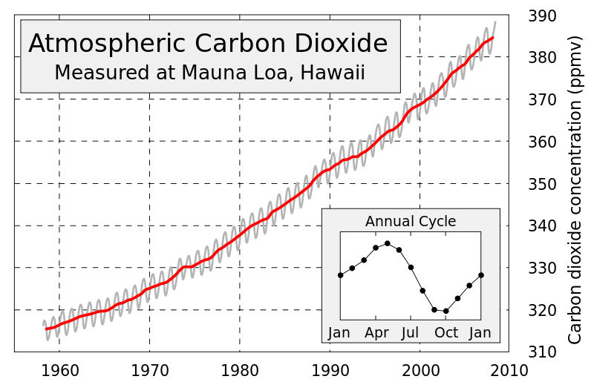

- Explain how your activities are increasing the amount of Carbon Dioxide in the atmosphere.

- Use information from the table to create two graphs to show:
 | % of global emissions | Population in December 2015 (Global Pop. = 7,387,943,081)
China | 24% | 1,367,485,388
USA | 12% | 321,368,864
EU | 9% | 507,000,000
Brazil | 6% | 204,259,812
India | 6% | 1,251,695,584
Russia | 5% | 142,423,773
Japan | 3% | 126,919,659
Canada | 2% | 35,099,836
D.R. Congo | 1.5% | 79,375,136
Indonesia | 1.5% | 255,993,674
  - The % of global greenhouse gas emissions from each country.
  - The size of the population of each country.

- Use your numeracy skills to:
- Estimate whether emissions for different countries are in line with their population sizes.
- Compare emissions against population for:
  - China and India
  - USA and the EU.

- For Carbon Dioxide and Methane explain the following concepts:

  - Emissions

  - Sinks

- Put the section heading Options.

- Using examples to help you explain the following concepts:

  - Technology Transfer

  - Adaptation

  - Mitigation

- Which countries will need to pay for this and why?

- How much money each year has been decided to start with?

- Put the section heading Decision.

- In Wales what could we do help ourselves with:

  - Adaptation and
  - Mitigation?

Think about the questions from the online resource.

- In Wales what could we do help ourselves with reducing emissions?

- Thinking especially about today what could you have done differently to reduce emissions?

- Write a list of proposals for the Welsh Government to help fight climate change.

- Justify reasons for the three most important things on your list.

