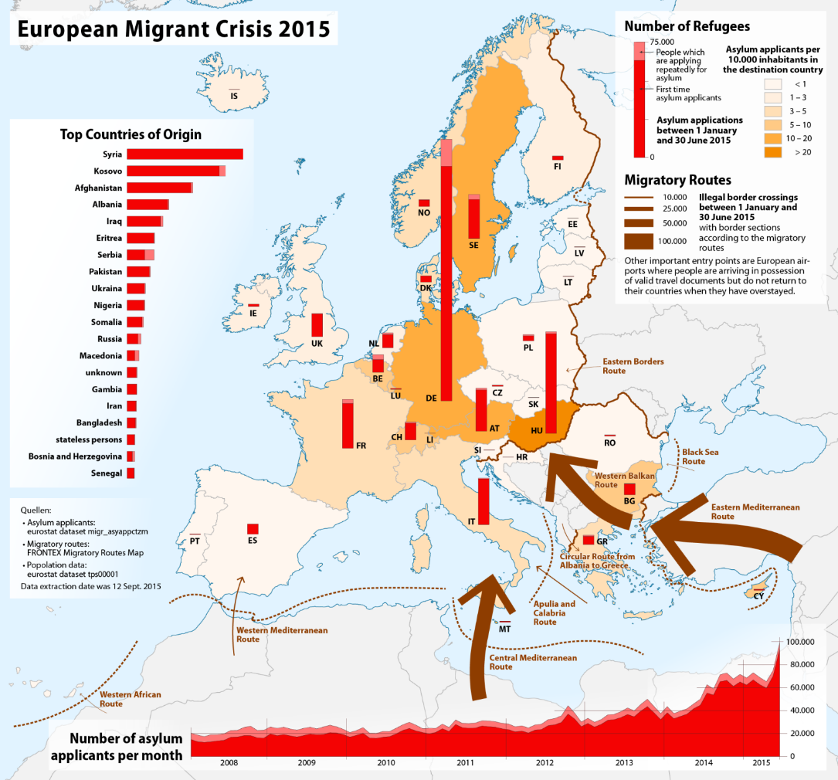
Student activity
Investigation
First try to read the rest of the online resources and follow each activity on this sheet to help you carry out an investigation of the regions supplying many refugees and migrants to Europe and some of the problems these areas are suffering from.

- Introduction
  - In this section you will explain what it is that you are investigating.
  - You will choose questions for enquiry that you want to answer.
  - You will explain important background information.

- Results
  - Use maps from the articles
  - Use photographs from the articles, online research & GIS.
  - Tabulate (put in tables) data.
  - Convert the data into easier forms to interpret:
    - Use graphs
    - Simplify data into rounded numbers or a representative mean.

- Analysis
- Show how your results answer your questions for enquiry:
  - Annotate graphs, photographs, maps and diagrams
  - Construct paragraphs.

- Conclusions
- For each of your enquiry questions what have you found out? What is the answer?

- Evaluation
  - Evaluate your process (how you carried out your investigations (methods)) – what was successful? What went wrong? What could you do differently next time?
  - Evaluate your sources – (your information and data) which are reliable and why? Which might be biased and why?
  - Evaluate your outcomes – (your conclusions) what is reliable and why? Which may be wrong or inaccurate and why?
  - Formulate more questions for a future enquiry based on your findings.

…………………………………………………..

- Use the Section heading Introduction before answering the following questions in the form of a paragraph (not separately):
  - What are migrants?
  - What are refugees?
  - What regions provide most refugees?
  - Are there any different countries or places providing migrants?

- Answer the following questions in the form of a paragraph (not separately):
  - Who ruled most of the Middle East before World War 1?
  - What was happening before this?
  - Up until the 7th Century what was the dominant Empire?
  - Where did this Empire come from?
  - Why is the Middle East sometimes called ‘The Cradle of Civilisation’?

- Answer the following questions in the form of a paragraph (not separately):
  - What was discovered in 1908?
  - Why might this be important?
  - What happened during WW1?
  - What happened after WW1?
  - Why was there disagreement in Palestine?

- Answer the following questions in the form of a paragraph (not separately):
  - What is Israel?
  - What two things happened to Israel in 1948?
  - How many conflicts in the Middle East since 1946?

- Explain why people might have had to flee from Iraq since 1990?

- Use a subheading of ‘Questions for Enquiry’ before completing these activities:
Try to write 3 or 4 of your own questions for enquiry based on secondary (collected by someone else) data (you will investigate to answer them for question 13) such as these examples:
  - Where do most refugees come from?
  - What happens in these places to force people to become refugees?
  - Are there other places which are providing migrants?
  - How have migrant numbers changed?
  - Why are migrant numbers changing?
  - How has recent (within past 30 years) conflict caused migration?

- Investigate (find information, data, graphs, photographs & Maps you will need this to answer question 14) these questions for Enquiry:

  - What events happened in Afghanistan that has resulted in refugees coming to Europe?
  - What events happened in Iraq that has resulted in refugees coming to Europe?
  - What events happened in North Africa that has resulted in refugees coming to Europe?
  - What events happened in Sub-Saharan Africa that has resulted in refugees coming to Europe?
  - What is so called Islamic State/ISIL?
    - How did it start?
    - Where is it today?
    - What has it done?

- Use the Section heading Results before answering the following activities:

Use suitable graphs, maps and photographs to help you to answer your Questions for Enquiry. You should cut up and annotate the European Migrant Crisis 2015 map sheet.

- Include tables and graph data that you find in your research.

- Use the Section heading Analysis before answering the following activities:

  - Annotate directly on and around your graphs, maps and photographs to show any information or pattern that helps to answer your Questions for Enquiry.

- For each of the graphs you have drawn or for each map that you have used write a paragraph that helps you explain what they show you, try to include things like:
  - Which map or graph are you writing about? What is its title? Can you give a page number?
  - Actual numbers; what is the highest? What is the lowest? What is the range (difference between highest and lowest)? What is representative of the average (either calculate a mean or approximate a rough value)?
  - What does this show you?
  - Why is it important?

- Use the Section heading Conclusions before answering the following activities:
For each of your enquiry questions from question 6 write a paragraph (do not answer these question individually but use them to help build up a paragraph) to show what have you found out?
    - What is the answer?
    - Where is your evidence (which maps or graphs)?
    - Do you have any actual numbers to back up your conclusion?

- For each of the enquiry questions from question 7 write a paragraph (do not answer these question individually but use them to help build up a paragraph) to show what have you found out?
    - What is the answer?
    - Where is your evidence (which maps or graphs)?
    - Do you have any actual numbers to back up your conclusion?

- What events happened in Afghanistan that has resulted in refugees coming to Europe?
- What events happened in Iraq that has resulted in refugees coming to Europe?
- What events happened in North Africa that has resulted in refugees coming to Europe?
- What events happened in Sub-Saharan Africa that has resulted in refugees coming to Europe?
- What is so called Islamic State/ISIL?
    - How did it start?
    - Where is it today?
    - What has it done?

- Use the Section heading Evaluation before answering the following questions in the form of a paragraph (not separately); use the question answers to choose what to include in your paragraphs.

- Evaluate your process (how you carried out your investigations (methods)):
  - What was successful?
  - What went wrong?
  - What could you do differently next time?

- Evaluate your sources – (your information and data):
  - Which are reliable and why?
  - Which might be biased and why?

- Evaluate your outcomes – (your conclusions):
  - What is reliable and why?
  - Which may be wrong or inaccurate and why?

- Put a subheading Important Issues.
  - What do you think might happen in the future in Afghanistan?
  - What do you think might happen in the future in Iraq?
  - What do you think might happen in the future in Libya?
  - What do you think is going to happen with so called Islamic State/ISIL?
  - What do you think is going to happen with Boko Haram?
  - Why are we at risk here in Wales?

- Put a subheading Further Questions for Enquiry.
  - Discuss ideas with a friend that you find important that you have not investigated.
  - Use some of these ideas to write some new questions that you could investigate in the future.

