- Define the following based on the Refugee Convention:
  - Asylum Seeker
  - Refugee

- What is an economic migrant?

- Scan the quote below to answer these questions:
  - By the end of 2014 how many people worldwide were forcibly displaced?
  - Which are the top six countries that hosted refugees?
  - Worldwide what % of refugees were hosted by rich developed countries such as the UK?

“59.5 million people worldwide were forcibly displaced at the end of 2014, as a result of persecution, conflict and human rights violations, the highest level on record. That was 8.3 million people more than at the end of 2013: the biggest annual increase ever in a single year. 19.5 million of those people were refugees. EU countries hosted a relatively small share of that number. At the end of 2014, the world’s top refugee host was Turkey, followed by Pakistan, Lebanon, Iran, Ethiopia and Jordan. Lebanon hosted by far the largest number of refugees by population, 232 per 1,000 inhabitants. Worldwide, 86 per cent of the refugees under UNHCR’s mandate lived in developing countries.”
Source: UNHCR Global Trends 2014, World at War

- Scan this quote from the 1951 Geneva Convention where a refugee is defined as a person who …

"… owing to well-founded fear of being persecuted for reasons of race, religion, nationality, membership of a particular social group or political opinion, is outside the country of his nationality and is unable or, owing to such fear, is unwilling to avail himself of the protection of that country; or who, not having a nationality and being outside the country of his former habitual residence … is unable or, owing to such fear, is unwilling to return to it."

- After scanning:
  - List 5 things that could make a person into a refugee
  - Where does someone have to be to become a refugee?

- Use the graph on the number of asylum applications compared to the size of a countries population.
The information is per million of the population.

  - Which country has the highest number?
  - How does the UK compare to the other countries in the EU?
  - What is its rank?

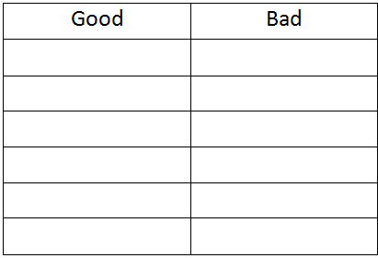
- Use the different resources to find numbers on how well the UK does in terms of helping with the refugee crisis.
  - Decide if these numbers make us look good or bad.
  - Show this in a simple table:

- Use a sketch to explain the push-pull model of migration.

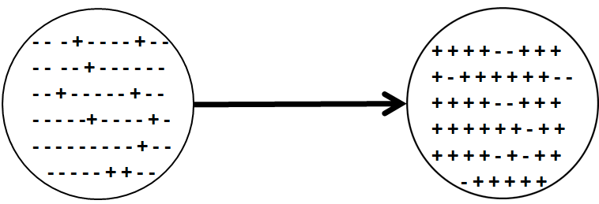

- Give one reason why the EU needs inwards migration
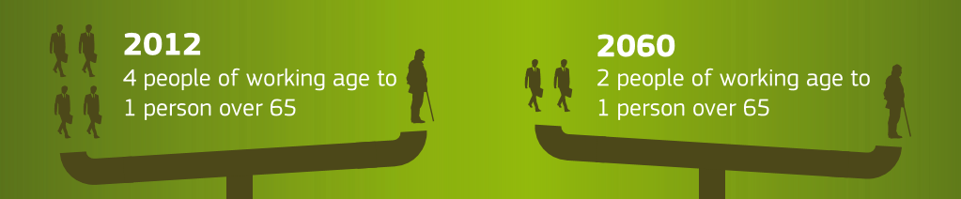

Decision Making Exercise

The first Minister of Wales is going to a meeting of the four leaders of Wales, Scotland, Northern Ireland and England to discuss a UK policy about the current migration crisis.

- Fair Hosting
Advise (say why you make your choice) the Welsh Government whether the United Kingdom government in London should:

- Keep accepting the same numbers of refugees.
- Accept fewer refugees.
- Accept more refugees.

- Pull Factors
Advise (give reasons for your advice) the First Minister on:
  - How other countries such as Australia have reduced the pull factors for migrants?
  - What might happen to future non-legal migration if all of the current non-legal migrants are rewarded by being given asylum.

- Push Factors
Decide (justify your choices) and advise on what you think are the best ways to reduce push factors such as:
    - War
    - Poverty
    - Persecution
    - Effects of Climate Change

- Advise (justify your advice) the First Minister on what should be done about:
  - Asylum seekers not registering in the first ‘safe country’
  - EU countries such as Hungary and Austria now refusing to register asylum seekers which is against international law.

