- Using the online resources and PDF resources identify 5 ways in which the ‘migration crisis’ of 2015 is negatively affecting the UK.

- Define the following based on the Refugee Convention:
  - Asylum Seeker
  - Refugee

- What is an economic migrant?

“59.5 million people worldwide were forcibly displaced at the end of 2014, as a result of persecution, conflict and human rights violations, the highest level on record. That was 8.3 million people more than at the end of 2013: the biggest annual increase ever in a single year. 19.5 million of those people were refugees. EU countries hosted a relatively small share of that number. At the end of 2014, the world’s top refugee host was Turkey, followed by Pakistan, Lebanon, Iran, Ethiopia and Jordan. Lebanon hosted by far the largest number of refugees by population, 232 per 1,000 inhabitants. Worldwide, 86 per cent of the refugees under UNHCR’s mandate lived in developing countries.”
Source: UNHCR Global Trends 2014, World at War

- Scan the quote above to answer these questions:
  - By the end of 2014 how many people worldwide were forcibly displaced?
  - How did this compare to 2013?
  - Which are the top six countries that hosted refugees?
  - Worldwide what % of refugees were hosted by rich developed countries such as the UK?

- Use the information in the table below to draw a graph to show the total numbers of asylum applications per European country so far in 2015.

Germany | 202,815
Sweden | 81,325
Italy | 64,625
France | 64,310
Hungary | 42,775
United Kingdom | 31,945
Austria | 28,065
Netherlands | 24,535
Switzerland | 23,770
Belgium | 22,850
Denmark | 14,715
Norway | 13,265
Bulgaria | 11,080
Greece | 9,435
Poland | 8,025
Spain | 5,615
Finland | 3,625
Cyprus | 1,745
Romania | 1,545
Ireland | 1,450
Malta | 1,350
Czech Republic | 1,155
Luxembourg | 1,150
Croatia | 450
Portugal | 445
Lithuania | 440
Slovenia | 385
Latvia | 375
Slovakia | 330
Iceland | 170
Estonia | 155

- Use the table below draw a graph to show the number of asylum applications compared to the size of a countries existing population. The information is per million of the population

Country | Per million of population
Sweden | 8,365
Hungary | 4,337
Austria | 3,282
Malta | 3,168
Switzerland | 2,890
Denmark | 2,605
Norway | 2,562
Germany | 2,513
Luxembourg | 2,043
Belgium | 2,016
Cyprus | 1,999
Bulgaria | 1,539
Netherlands | 1,454
Italy | 1060
France | 972
Greece | 859
Finland | 662
Iceland | 517
United Kingdom | 494
Ireland | 315
Poland | 208
Latvia | 189
Slovenia | 186
Lithuania | 152
Spain | 121
Estonia | 118
Czech Republic | 110
Croatia | 106
Romania | 78
Slovakia | 61
Portugal | 43

- Use the online resource and/or the PDF resources to find different pieces numerical information on how well the UK performs in terms of contributing to the global refugee crisis. Show this in a simple table:

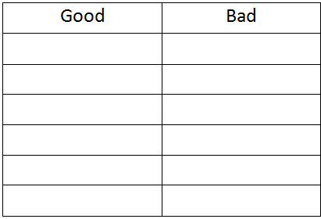

- Scan this quote from the 1951 Geneva Convention where a refugee is defined as a person who …

"… owing to well-founded fear of being persecuted for reasons of race, religion, nationality, membership of a particular social group or political opinion, is outside the country of his nationality and is unable or, owing to such fear, is unwilling to avail himself of the protection of that country; or who, not having a nationality and being outside the country of his former habitual residence … is unable or, owing to such fear, is unwilling to return to it."

- After scanning:
  - List 5 things that could make a person into a refugee
  - Where does someone have to be to become a refugee?

- What is the main international law for a genuine asylum seeker/refugee?

- What are the two main international laws for a country?

- What are the Schengen Countries of the EU?

- Why do migrants want to get to a Schengen country?

- Why do so many migrants by sea take the more dangerous journey to Italy rather than the safer journey to Greece?

- Why don’t many migrants by sea go to Spain?

- Use an annotated sketch to explain the push-pull model of migration.

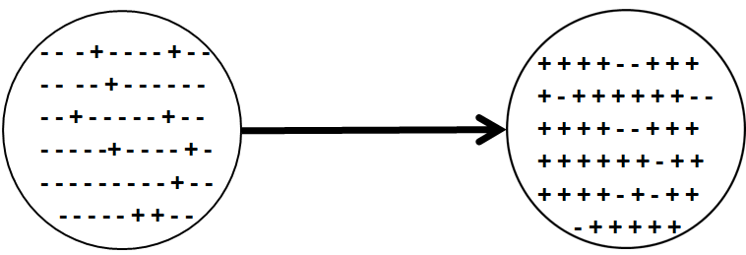

- How might more wealthy, educated & ‘safe’ people from poorer countries end up in developed nations such as the UK?

- Who benefits most from people smuggling?

- How might this increase international terrorism and war?

- How has Australia (and also Spain) reduced the pull factors for non-legal migrants to enter their countries?

- Give one reason why the EU needs inwards migration

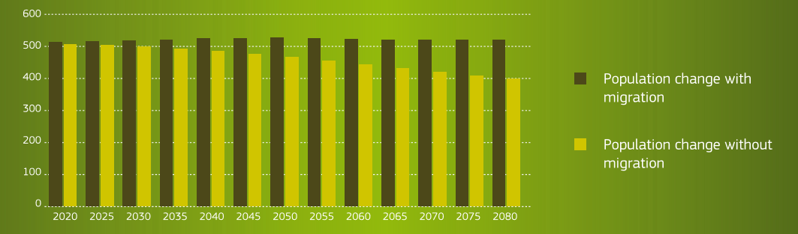
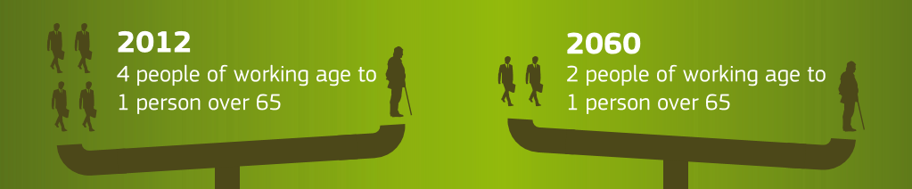

- Scan the information in the graph showing the distribution of funds from AMIF (Asylum & Migration Integration Fund):

  - Which country gets the biggest share of the money?
  - How does this compare with your graph for activity 4 of asylum seekers per million of the population?
  - Does this seem fair to you?

AMIF in Euros

- What will happen to the overall EU population without inwards migration?
Decision Making Exercise
First try to read the rest of the linked resources and attempt to complete the student resource sheet.

The first Minister of Wales is going to a meeting of the four leaders of Wales, Scotland, Northern Ireland and England to discuss a unified policy to present to the British public about the current migration crisis.

- Fair Hosting
As a geographer decide (give reasons why you chose your option and did not choose the others) and advise the Welsh Government whether the United Kingdom government in London:

- Keep accepting the same numbers of refugees.
- Accept fewer refugees.
- Accept more refugees.

- Pull Factors
As a geographer advise (justify your advice) the First Minister on:
  - How other countries such as Australia have reduced the pull factors for migrants?
  - The likely impacts to future non-legal migration if all of the non-legal migrants in the EU at the moment were granted asylum or residency.

- Push Factors
As a geographer decide (justify your choices) what are the best ways to reduce push factors such as:
    - War
    - Poverty
    - Persecution
    - Effects of Climate Change

- As a geographer advise (justify your advice) the First Minister on what should be done about:
  - Asylum seekers not registering in the first ‘safe country’
  - EU countries such as Hungary and Austria now refusing to register asylum seekers which is against international law.

