What Will We Do About Coastal Flooding?
Decision Making Exercise

Imagine you have been appointed as a specialist advisor from the Wales Coastal Monitoring Centre – W.C.M.C.

You will be asked to write a brief report outlining the issues on a section or sections of the coastline in Wales. You will need to:

- Give a background summary of issues identified as a result of the storms of Winter 2013/14.

- Explain the options for your section or sections of coastline:
  - No Active Intervention (N.A.I.)
  - Hold the Line (H.T.L.)
  - Managed Realignment (M.R.)
  - Advance the Line (A.T.L.)

- Describe (use maps to help you to do this) the current preferred option for your chosen location or locations in the S.M.P.’s for:
  - Epoch 1 (short-term) = years 0 to 20.
  - Epoch 2 (medium term) = years 20 to 50 and.
  - Epoch 3 (long term) = years 50 to 100.

- Your Decision:
  - Either justify why you think this is the best option or
  - Provide an alternative plan and justify why you have changed it.
…………………………………………………..

- Use the Section heading Introduction before answering the following questions in the form of a paragraph (not separately):

  - What is coastal flooding?
  - What happened in December 2013?
  - What happened in January 2014?

- Use this quote to help you explain what scientists think might happen in the future.

“Projections for the future of our coastal areas are of increasing risk, as a consequence of climate change and in particular sea level rise.”

- Use this quote to help you explain what the IPCC said in 2014 about temperature change and sea level change.

“The Intergovernmental Panel on Climate Change (IPCC), Fifth Assessment Report estimates that global temperatures have risen 0.85°C from 1880-2012. There has been an associated rise in global sea level which is now increasing at approximately 3.2 mm per year. The IPCC state that it is very likely that the 21st Century sea level rise rate will exceed the 1971-2000 rate, for all modelled emissions scenarios. “

- Use this quote to help you explain how an expected sea level increase of 0.5 metres would affect how frequent sever sea level events would be.

“A central estimate of 0.47m increase is projected by 2081-2100, relative to the 1986-2005 baseline. An increase of 0.5m is estimated to result in 10-fold to 100-fold increase in the frequency of sea level extremes (relative to present day) in northern Europe by the end of the century. This would mean a coastal flooding event that has a return period of 100 years at present will potentially occur on average between every year and every ten years by 2100.”
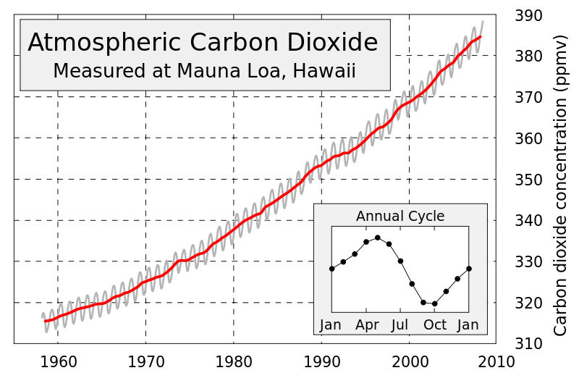

- Describe what this graph is showing you and explain how it could affect coastal flooding.

- Identify other possible reasons why there is an increased risk of coastal flooding around Wales.

- Use the following headings to show the different ways that we have to approach coastal flooding in Wales:
  - Progressing the Recommendation
  - Storm Severity
  - Flood Forecasting
  - Flood Warning & Community Response
  - Operational Response
  - Coastal Defences
  - Infrastructure Resilience

- Explain how each of the following recent developments are important in reducing coastal flooding:
- Creation of the Flood Forecasting Centre in April 2009. It is fully operational 24 hours a day, 7 days a week.
- Improvements in the quality of the U.K. weather forecast information.
- Improvements in the coverage and quality of flood forecasting and flood warning service.
- Improvements in the understanding of coastal erosion risk and mapping.
- The work of ‘Flood Awareness Wales’ to expand local understanding and community preparedness for flooding.
- Investment in the construction of new coastal defences, such as Borth, Riverside at Newport and Fairbourne.
- Investment in the maintenance and reconstruction of existing coastal defences such as the Tidal Clwyd Embankments.

- Put the section heading Options.

- Explain the meaning of the following options:

  - No Active Intervention (N.A.I.)
  - Hold the Line (H.T.L.)
  - Managed Realignment (M.R.)
  - Advance the Line (A.T.L.)

- Using a map to help you; identify the management options for a particular section of coastline for each of the three epochs:

  - Epoch 1 (short-term) = years 0 to 20.
  - Epoch 2 (medium term) = years 20 to 50 and.
  - Epoch 3 (long term) = years 50 to 100.

- Put the section heading Decision.

- Either justify why you agree with the decisions made in the S.M.P. or provide an alternative plan and justify why you have changed it.

- Look at recommendations for other sections of the coastline that you do not agree with and provide alternatives and justify them.

