

# Temperature Patterns

The temperature varies throughout the UK from one time of the year and from one place to another. Ask your teacher for a temperature map of the UK for July.

A) On your map, join up the dots that have temperatures of 15°C and 13°C. Draw your line lightly in pencil at first in case you make a mistake and draw your line with smooth curves.

B) Colour in your map using the key provided. Remember that colour should convey messages.

C) On your map, label the **warmest** and **coldest** parts of the UK.

D) On your map of the UK for January join up the dots that have temperatures of 5°C and 7°C. Colour your map in according to the key. Label the **mildest** and **coldest** parts of the UK.

The climate is the average weather conditions for a place based on the last 30 years. It tells us what we should expect the weather to be like at a particular time of the year. Of course, the weather will often be different to what we expect!



The lines you have drawn have joined up places of equal temperature. These lines are called **isotherms.** The isotherms show you that there are two different geographical patterns of temperature in the summer and in the winter.



1. Write a definition for the term **isotherm.**
2. Write a definition for the term **climate.**
3. Describe the geographical patterns of temperature in summer and winter in the UK.
4. Mark Pontypridd on both your maps. Work out the January and July Temperatures for Pontypridd. What is Pontypridd’s annual temperature range?
5. Look at the picture below. Using the diagram explain why it is warmer in the south of the UK during the summer.
6. Why is it warmer in the west of the UK during the winter?

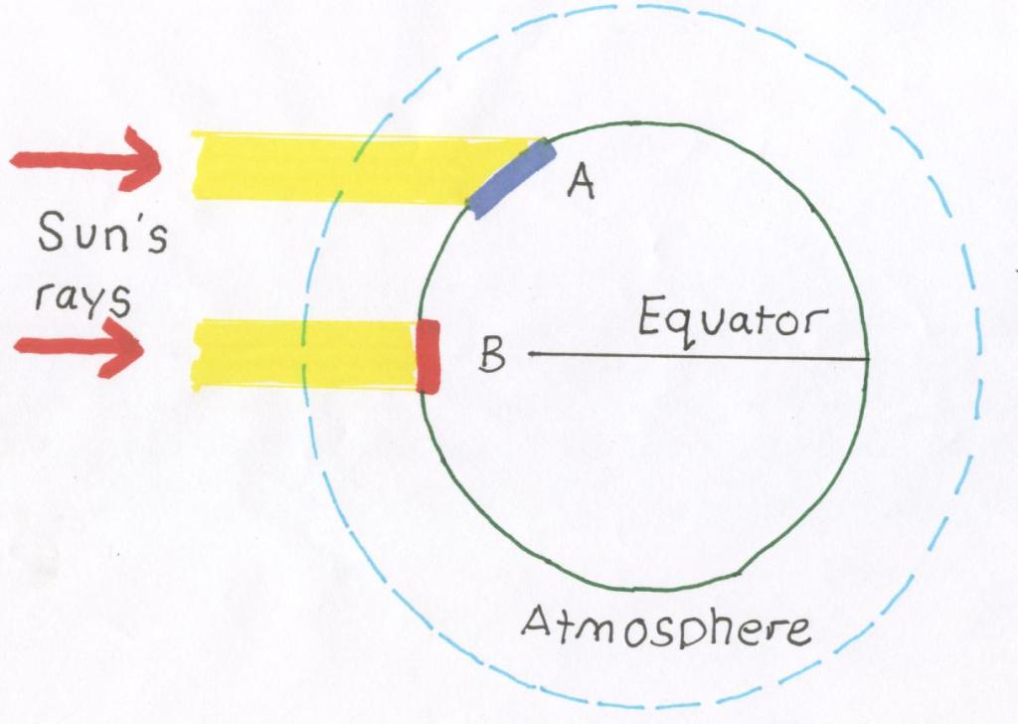

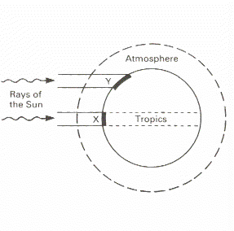

Make sure that you draw your diagram accurately. Use a compass to draw the circles and a rule to draw the straight lines.



There is a warm ocean current which passes the western side of the UK. This warm ocean current is called the **North Atlantic Drift (Gulf Stream).** It brings water from the Gulf of Mexico a much warmer tropical part of the World. This warm water raises the temperature in the west of the UK. The effect is only noticed in winter when land temperatures are lower.

The North Atlantic Drift

1. Why are mountain areas colder than lowland areas?
2. Why is the temperature inland warmer in summer than in winter?



As you climb in height it becomes colder. Temperature drops about 1°C for every 100 metres you climb. This called the **lapse rate.** Mountaineers and climbers have to take plenty of extra warm clothes.



Water takes longer to heat up than land. It is also able to store heat longer.



This means that in summer the sea is usually cooler than the land, but in winter is usually warmer.

**Temperature Patterns Controlled Assessment**

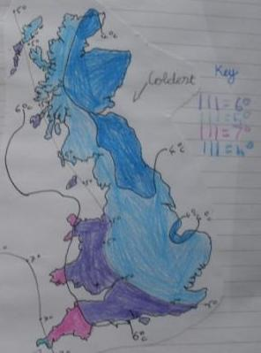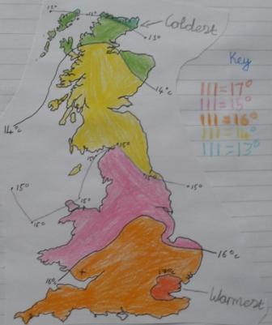

1. **Describe the temperature pattern for the UK in summer.**
2. **Explain the temperature pattern for the UK in summer.**
3. **Describe the temperature pattern for the UK in winter.**
4. **Explain the temperature pattern for the UK in winter.**
5. **How might the temperature patterns affect human activities?**



WILF SAYS

|  |  |
| --- | --- |
| **Level 2** | You give a simple description of which places in the UK are warmer or colder in either the summer or winter. |
| **Level 3** | You give a basic description of which places are warmer or colder in the summer or winter. |
| **Level 4** | You begin to describe temperature patterns using terms such as compass directions or names of places in the UK. You offer very simple explanations of why these patterns might occur. |
| **Level 5** | You describe temperature patterns using compass directions and place names. You offer explanations for these patterns giving at least one reason for the summer patterns and one for the winter. |
| **Level 6** | You describe temperature patterns using compass directions, place names and actual temperature values from the maps. You offer one or more reasons to explain these patterns. |
| **Level 7** | You describe temperature patterns using compass directions, place names and actual temperature values from the maps. You give good explanations for these patterns and probably include sketches. You describe how these patterns affect human activities such as farming, tourism and transport. |
| **Level 8** | You describe temperature patterns using compass directions, place names and actual temperature values from the maps. You give good explanations for these patterns and probably include sketches. You describe and explain how these patterns affect human activities such as farming, tourism and transport. |



We always seem to complain that it is raining but some places receive much more rain than others places do.



1. Make a copy of the rainfall map. Shade in your map according to the key. Places with over 1,500mm should be black, places with between 750 and 1,500mm should be blue and places with less than 750mm should be yellow.
2. Which area of the UK receives the most rain and which area receives the least?
3. Describe in detail the geographical pattern your map shows.

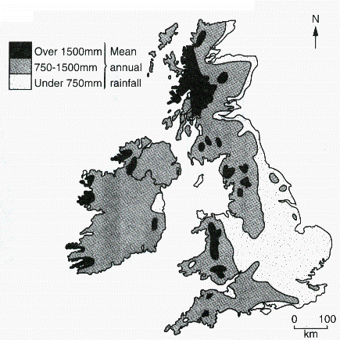







For rain to form, a lot of things need to happen to the air above a certain place. First, water has to get into the air. This happens by evaporation from surface water sources. This means that water vapour is stored in the air. In order to turn the water vapour back into a liquid condensation must take place. For condensation to take place the air must get colder. Air is cooled when it rises. As you have already learned, the higher we go the colder it gets. This is called the **lapse rate.**



There are three main ways that air can be forced to rise. Each one is shown in the picture below. Draw your own labelled pictures to show these three main ways of causing rain**.**

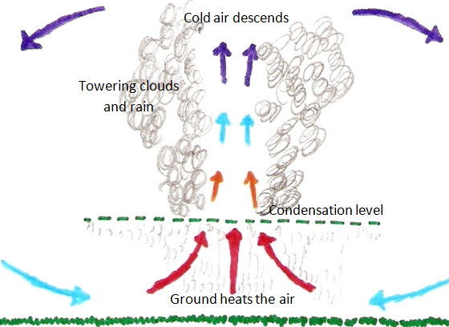

**Convectional** **rainfall** is caused when air close to the warm ground surface rises because it is warmer and lighter than the surrounding air.

**Frontal rainfall** occurs when warm and cold air meets. The two types of air do not mix. Where they meet is called a **front**. The warm air is forced upwards by the cold air.

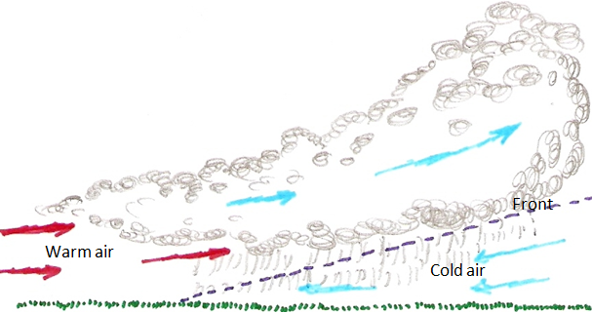

**Relief rainfall** Occurs when a body of warm moist air meets a mountain or other area of high relief. The air is forced up over the high ground

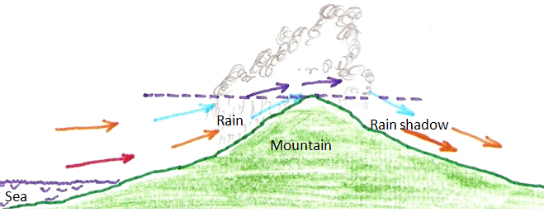

Look at the map of highland and lowland Britain. Use a relief map to explain the wettest places in the UK that you see on your rainfall distribution map. You will find a more detailed map online or in an atlas. Try to name some of the areas of high relief in your answer

