Why do we get seasonal temperature patterns?

In Wales there are two main influences on the temperature. To understand them, let’s take a look at these patterns on some maps.
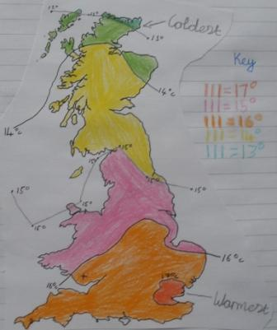
Summertime temperature patterns
The map shows that there is a clear North-South pattern. To the north of Scotland temperatures are below 13°C (55.5F), but in the South they are over 16°C (60F). Around London in the South East of England they are over 17°C (62F).

In Wales the south-east is over 16°C (60F) but the rest of Wales is between 15°C (59F) and 16°C (60F) except the northern tip of Anglesey which is between 14°C (57F) and 15°C (59F).

(Map drawn by a Year 7 geography student)

, diagrams and explanations have been prepared by a).
The reason for these patterns in temperature can be explained by the following diagram. This shows what happens to the rays of the sun when they enter Earth’s atmosphere and strike the surface.

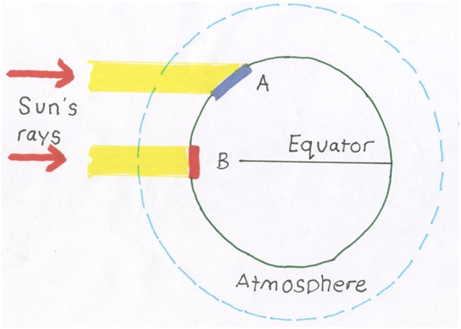
The sun’s rays have to pass through a thicker atmosphere at point A compared to point B. This means that point B gets more warmth than point A.
At point A the rays of the sun are spread over a bigger area than at point B (which is on the line of the equator). This happens because light travels in straight lines, but then hits the Earth which is round.

This explains why it is warmer in the South and colder in the North during Britain’s summer time.

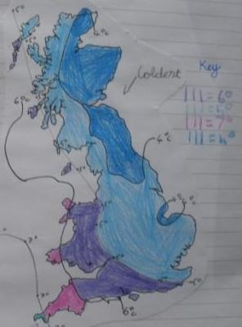
In January it is colder in the East and warmer in the West. Around the East of Scotland and the Wash in England the temperatures are below 4 °C (39F). In the West of Britain, especially those areas such as West Wales and the English West Country, temperatures are between 6°C (42F) and 7°C (44F). In the far western tip of Cornwall temperatures are over 7 °C (44F).

Most of Wales is between 5 and 6°C ( in January. The western edges such as Pembrokeshire, the Lleyn Peninsula and Anglesey are between 6°C and 7°C.

The reason for this East-West pattern during the winter has little to do with the sun. In the winter the rays of the sun are too weak to have a major impact on temperature patterns. This is because they cannot warm the land to a temperature greater than the sea so the sea has the greatest impacts on our temperature patterns.

To the West of Wales and the UK is a large ocean (The Atlantic). In the winter the Atlantic acts as a giant hot water bottle and helps keep western areas warm. To the East of the UK is a large continental area (Europe and Asia) separated by just a narrow sea. Continents cool down rapidly and the centre of Europe and Asia in Russia usually gets down below 20°c in the winter. This acts like a freezer with the door left open chilling the East of the UK.

If air from the continent moves over us, it picks up moisture as it passes over the North Sea and then drops it on us as snow. This is what happened in the winter of 2010 when many schools in Wales were shut by snow.

Brain Box
Specific Heat Capacity
This is the amount of heat energy required to change the temperature of a body by 1°c. Land has a lower Specific Heat Capacity than water. This means that land areas heat up more quickly in summer and cool down more quickly in winter.

In the summer the sea acts to cool the hot land but in winter the sea warms the land.

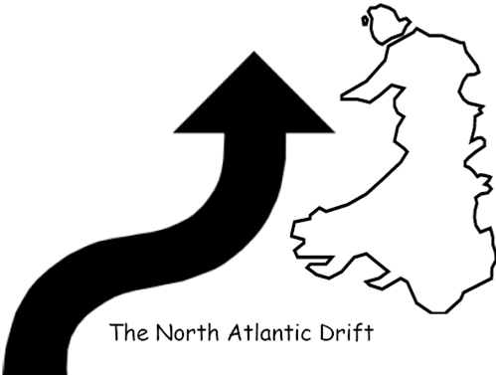
The ocean off the west coast of Wales however is even warmer than can be explained by differences in Specific Heat Capacity between water and the land. In fact there is a warm ocean current called The North Atlantic Drift which is just like a vast river of warm water within the ocean. This current is carrying heat from the tropical region around the Gulf of Mexico to the Polar Regions to the North of the UK. Diving in this current off the coast of West Wales you could see all kinds of Tropical sea life. This current helps to make the West coast much warmer.

Areas of high relief (mountains) have a big impact on temperatures patterns (and rainfall patterns). If you were to go up in the air in a hot air balloon and take the thermometer with you would record a drop in temperature. This is because as air rises it expands and pushes the air around it – in other words it does some work so uses up energy. This loss of energy is in the form of heat so the air gets colder. Dry air cools at a rate of 9.8°c per 100metres or very nearly 1°c per 100 metres. Air containing moisture cools at a slower rate. This cooling with altitude is called the lapse rate.

Brain Box
How do temperature patterns affect people?
The temperature patterns have a big impact on certain economic activities (to do with work and money). The two biggest activities affected are farming in tourism. In the West of Wales the warmer winter temperatures mean that the growing season starts early so farmers can make extra money by planting early season new potatoes and salad crops. In the East of the UK the late frosts means that these crops can only be grown later in the year when prices are lower. However the hot summers are perfect for ripening crops such as wheat so these are often grown.

In 2010 UK wheat farmers had a bumper harvest thanks to our climate up by 5% on 2009. Around the world however it is a very different story because 2010 has been a year of weather disasters. Russia and the Ukraine have stopped exporting wheat and barley after droughts and fires devastated their harvests. Parts of Australia were first hit by droughts and then by heavy rains and China and India have had some of the worst weather in their history. Across Africa in countries such as Niger droughts followed by floods have caused widespread hunger. All eyes are now on the USA for a good harvest and then the next harvest in the Southern Hemisphere where hopefully the Argentina crop and the next Australian crop will help fill the hole.

Areas in the South of the UK are usually hotter so they have developed beach based tourism; very few people go swimming on the beautiful beaches of Northern Scotland! However the cold temperatures in the East of Scotland and the high mountains have combined to provide ski resorts such as Glen Shee.

Activity
Activity using maps and diagrams describe and explain the UK temperature patterns in summer and winter.

Extension Activity
How do these temperature patterns affect human activities?

