Rain stops Ryder Cup!

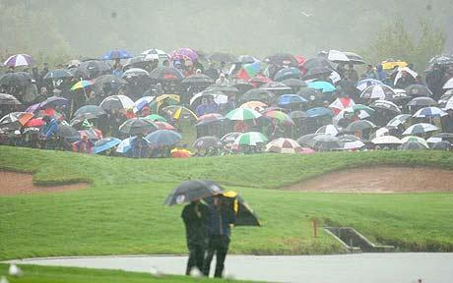
Golf is an ‘all weather’ sport; it can be played in the sun and even in the rain - unless you’re in Wales that is!

When the Ryder cup came to Wales; organisers were hopeful for some challenging weather conditions – but as any geographer could tell them – be careful what you wish for when it comes to the weather in Wales in October (or any time of the year for that matter).
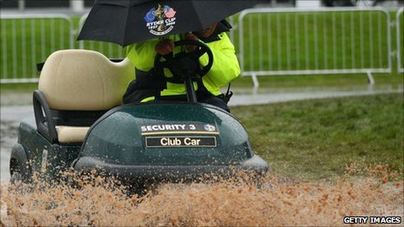
In recent years, Wales has suffered some incredible downpours of rain and some very extreme weather. What is it about the geography of Wales that creates our unique climate and weather?

Brain Box
What is weather and climate?
Weather is the condition of the atmosphere (the layer of gas surrounding the Earth) in a place at a particular time. It can include how hot or cold it is or how cloudy, windy or if there is any precipitation (any type of water coming from the sky to the surface such as rain, drizzle, snow, hail, fog, mist, sleet & rime).

Climate is the average of the weather conditions over a period of time (usually 30 years) it tells us what to expect of the weather, not what the weather will be.

Why do we get a lot of rain in Wales?

Rain is made in two main ways:

- Rising air
When air rises, it expands and cools at the same time. As it expands, it uses energy. This energy is lost in the form of heat so it gets colder. Dry air cools at a rate of 9.8°c per 100metres or very nearly 1°c per 100 metres.

Air containing moisture cools at a slower rate. As it cools, any water it is carrying condenses to form tiny droplets (less than 0.2mm). If the air rises further these droplets freeze and become snow flakes. If they get big enough they get pulled down by gravity and melt as they fall to make a raindrop. Most rain in Wales is made this way which is why our rain drops are usually so cold!

- Wind currents
As air rises, tiny water droplets can form. Strong wind currents push these around causing them to collide. When they collide, a raindrop forms. This type of rain is common in tropical countries. This sometimes happens in Wales in the summer time, especially during thunderstorms which is why raindrops can often feel warm.

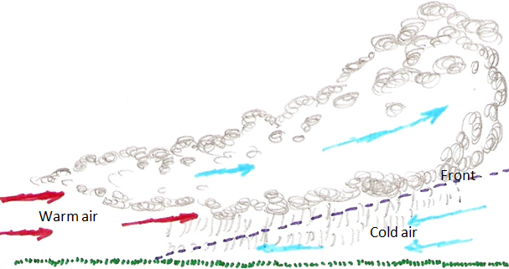
Where we are positioned in the world causes a lot of our rain. We are in the mid-latitudes - close to the middle between the North Pole and the Equator. This means that cold air from the polar region meets warm air from the tropical region in our latitude. Different types of air do not mix easily and stay separate – the boundary between them is called a front. (Fronts were first observed by scientists during the First World War. Armies were opposing each other, but faced each other along a line of trenches called a front. They decided the two different types of air were behaving in the same way and so the name has stuck ever since). The cold air is heavier and denser so it pushes under the warm air – as the warm air is pushed higher it gets colder, water droplets form, then freeze and then if they fall to earth and melt, rain drops are formed. This is called frontal rain.

A lot of frontal rain forms over the Atlantic Ocean to the West and South of us. However this is also the direction that our winds blow from for most of the time, so there are a lot of frontal rain ‘systems’ dragged over us.

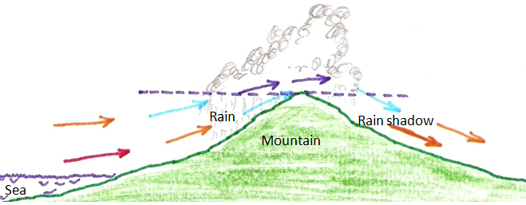
Wales is a very hilly and mountainous country so when any air moves over us it is forced to rise and this causes relief rain. Any area to the south and West of the Hills can get a lot of rain this way. Areas such as England to the east of the welsh mountains are in the rain shadow which means they get a lot less rain than we do.

During the Ryder Cup two different fronts hit Wales from the South causing a combination of frontal rain and relief rain in Newport on the Friday and then the Sunday – unlucky but not unusual in a Wild Welsh Autumn.
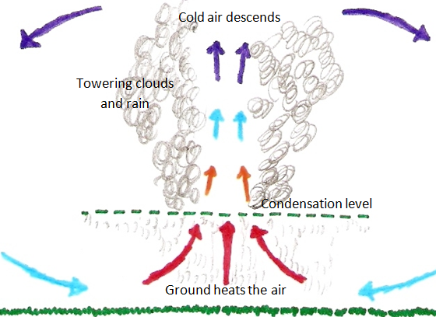
In hot conditions, rain in Wales can form the same way as it does in the tropical countries. The sun heats the ground and the ground heats the layer of air above it. As the air warms the molecules move further apart and the air becomes less dense (lighter) than the overlying air. As a result it rises just like a hot air balloon. Within the rising air there are strong currents (updrafts and downdrafts) which cause the droplets created by condensation to collide and merge to form raindrops. Rain formed in this way is called convectional rain.
Activity – Article 1
Draw a rainfall map of the UK - Explain why places in Wales receive far more rain than places in the East of England such as London.

