High Speed Trains Electric Trains are ‘in’ for some, but not all of South Wales.
The Government has confirmed that the railway line between Cardiff and London is to change from diesel to electric power. The plan expects the electric trains to begin in 2017 as it will take that much time to complete the construction of new equipment along the lines. There are also plans being prepared to electrify the important commuter ( daily worker travel) trains that link Cardiff to nearby towns to the north and west (e.g Treherbert, Aberdare Merthyr Tydfil, Rhymney, Penarth and Barry).
So what are the advantages of electric power that make these very expensive changes worthwhile?
- They are faster and get up to top speed quicker. Journeys to London could be 20 minutes shorter as a result and 15 minutes less for a morning journey into Cardiff from Merthyr Tydfil. The Welsh Assembly hopes this will help both workers and companies; making South Wales more connected and competitive within the UK.
- They pollute less as they do not burn diesel fuel in the engine and make less noise.
- They use energy efficiently and so should have cheaper running costs.
However there was disappointment in Swansea and West Wales when the announcement rejected the additional plan to electrify the line to Swansea. This is because the number of trains and passenger totals were thought to be too small to pay back the £62 million investment costs. Organisations like Friends of the Earth say that this is wrong as the improved service would create more use of the railway and it would be a help to develop business in the more remote areas of South West Wales.

The Scottish independence debate and Wales

Scotland has a partly separate (devolved) government just like Wales. The main political party in Scotland is the Scottish National Party (SNP) and they have promised the Scottish people a vote (called a referendum) in the next 2 years for, or against, becoming fully-independent from the rest of the UK. Both the SNP and the Westminster government are actively campaigning on this issue and will be doing so for the next 2 years in to prepare the Scots to vote wisely.

Since both Wales and Northern Island have similar government structures to Scotland, a vote for Scotland to leave the UK will have an impact on Wales. The Welsh nationalist party (Plaid Cymru) wants Wales to become fully independent as well, though up to now, sample votes in Wales have shown that only 10-20% of Welsh residents would be in favour of Welsh full independence from the rest of the UK.

If Scotland does vote to be fully independent, it will lead the way for much more debate on whether the Welsh Assembly should follow the Scottish lead and have another yes/no referendum in Wales.

Even more Enterprise Zones for Wales!

Geography in the news autumn 2011, issue 13 mentioned the setting up of five business enterprise zones in Wales to encourage now industries and jobs.
Anglesey will focus on energy and environment.
Cardiff will be the destination for financial and professional services.
Deeside will specialise in advanced manufacturing.
Ebbw Vale aims to attract “innovative UK and international manufacturing companies, due to the quality of the local workforce “
St Athan concentrates on the aerospace sector with investment in aircraft maintenance facilities, international travel and route development, high quality business accommodation and links to universities.

Two more have been proposed.

The first of these is Pembrokeshire; where plans are to further develop the international port status of Milford Haven and Pembroke.
The second is in Gwynedd; where the closed nuclear power station at Trawsfynydd could provide a focus on the energy, environment and ICT sectors.
Another new tribe discovered in the Amazon rain forest!
Most people now think that every human community on Earth has now been discovered and knows that the rest of the world exists. In the last 20 years, some tribes in Amazonia changed from a state of no communication with the outside world to having internet access, with all the knowledge that brings, all in a matter of a few years!
It is therefore amazing news that another tribe has recently been discovered in the Peruvian jungle that surrounds the upper Amazon River. The Tribe has been named the Mashco-Piro and has had little, if any, peaceful contact with the outside world, but as is the case with so much of the Amazon rainforest, gas and oil exploration, forest burning, logging and tourism are pushing into their tribal area.
So far they have avoided aggressive defence, firing warning blunt arrows but it is clear they want to be left alone.
Protecting the tribe by setting aside a ‘traditional land area’ is a task for the Peruvian Government. It is a difficult and expensive job when the area is so remote; the people don’t want contact and can’t be easily found, and there are so many other pressures, both legal and illegal chipping away at the forest surrounding them.

Dan-yr-Ogof show cave - now a zero-carbon tourist attraction in Wales.

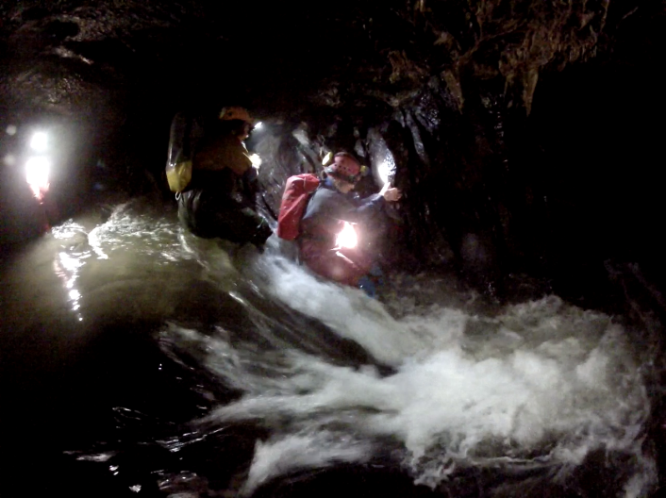Dan-yr-Ogof is the biggest commercial tourist attraction in the Brecon Beacons. There complex contains 3 show caves, exhibition buildings, a huge dinosaur park and tourist accommodation, all of which need heating and lighting. The whole attraction uses lots of electricity at £1,000 a week, enough to produce 185 tonnes of carbon into the atmosphere a year.

The river running (seen here rushing down a waterfall inside the cave) has a large flow (discharge) in winter and summer, and since the water runs out of the cave entrance about 50m. Above the Tawe valley floor, there is enough of height to run a hydro-electric power station.

This has now been constructed and the complete tourist attraction can now be self-sufficient in electricity.
Image: Courtesy of Andy Freem

The African Union has a new building!
Now this might seem a boring news item of no interest to you but behind it is a really important fact that you need to know.
The continent of Africa has a history of difficulties and disasters such as wars, epidemics and famines. Most African states are in great need of help to develop. Although western nations give aid to many African countries, there is much criticism about who the money goes to and for what purpose.
Africa has got lots of natural resources and the country in the modern world needing these resources and with most buying ability is China. Throughout Africa, China is setting up companies, paying for road and railway development and buying raw materials.
African nations are all represented by an organisation called “The African Union” - and it needed somewhere permanent to meet. The new 20-storey A.U. headquarters building in Addis Ababa (Ethiopia), was opened on 31st January 2012.
It was built and paid for by the Chinese, not by Africans.
It is very clear that China is very actively strengthening its trade, financial and political links with African countries. This trend is likely to affect the future of Africa and how it links to other areas of the World including the UK.

