- For each of the following ‘Domains’ rank yourself from A (lowest) to E (highest).

- Income
- Employment
- Health
- Education
- Access to Services
- Community Safety
- Physical Environment
- Housing

- The 10% which is most deprived (worst off).
- Between 20%-10% which is the next most deprived (worst off).
- Between 30%-20% which is the next most deprived (worst off).
- Between 40%-50% which is the next most deprived (worst off).
- The 50% (Half) of Wales that is least deprived.
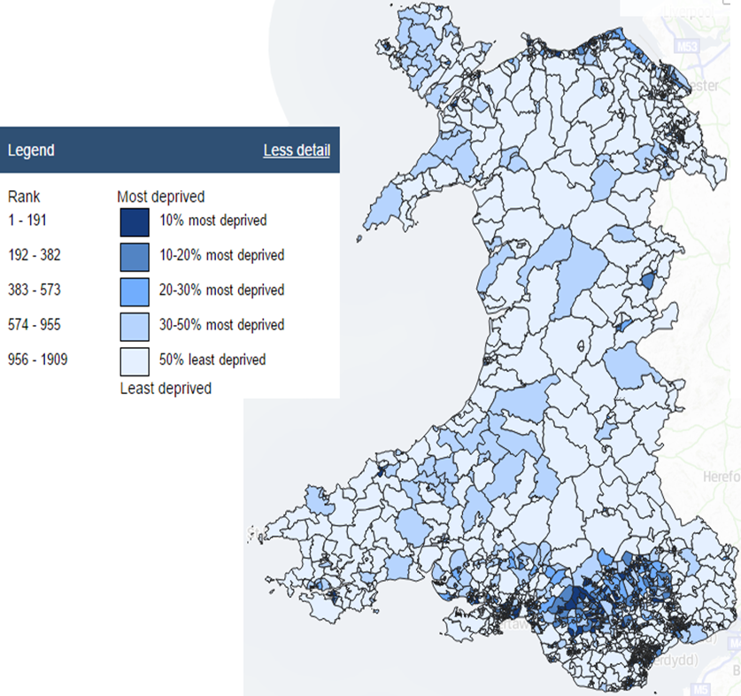

- Rank each locations from 1 most deprived area to 9 least deprived:

  - Llandudno
  - Anglesey
  - Cardigan
  - Pembroke Dock
  - Swansea
  - Merthyr Tydfil
  - The Valleys
  - Newport
  - Cardiff

- Rank the regions of Wales from 1 most deprived to 4 least deprived.

  - North Wales
  - South Wales
  - West Wales
  - Mid Wales

% All Individuals Living in Poverty
UK | 21
Wales | 23
Scotland | 19
Northern Ireland | 20
England | 22
England (SE) | 18
- Draw a graph to show % of all individuals living in poverty in the nations of the United Kingdom.

% Children Living in Poverty
UK | 29
Wales | 30
Scotland | 23
Northern Ireland | 26
England | 29
England (SE) | 26

- Draw a graph to show % of all children living in poverty in the nations of the United Kingdom.

- What do your graphs tell you about levels of poverty in Wales?

- Draw graphs to show weekly and annual earnings in Wales, Scotland, Northern Ireland, England and London.

Earnings (2016) | Weekly | Yearly
UK | £644 | £33,488
Wales | £566 | £29,432
Scotland | £623 | £32,396
Northern Ireland | £578 | £30,056
England | £652 | £33,904
England (London) | £832 | £43,264
England (SE) | £669 | £34,788

- What do your graphs show you about earnings in the UK?

- Try to draw a graph of the earnings in the table below.

Cleaners | £8,067
Beauticians | £12,418
Prime Minister (UK 2017) | £142,500
Police | £39,346
Farmers | £24,520
First Minister (Wales 2017) | £140,000
Doctor | £70,646
Teacher | £32,547
Nurse | £26,158
AM’s (Wales 2017) | £65,334
MP’s (UK 2017) | £74,962
Firefighter | £28,183
Farmers | £24,520
Plumber | £27,832
Adelle | £27,540,000
One Direction | £59,330,000
The Queen | £36,100,000
Michael Jackson (deceased) | £108,108,000

- What did your attempts tell you about the levels of income for popstars compared to normal workers? How do you feel about this?

- What did your attempts tell you about the importance of an education?

- Use pictures to show the differences between people from around the world.

Try to show what life is like for a wide range of people at different levels of wealth and for a typical family in Wales.

