Issues
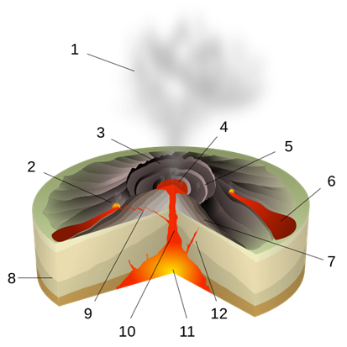
- Put the section title Issues.

- Draw a labelled sketch of a shield volcano.

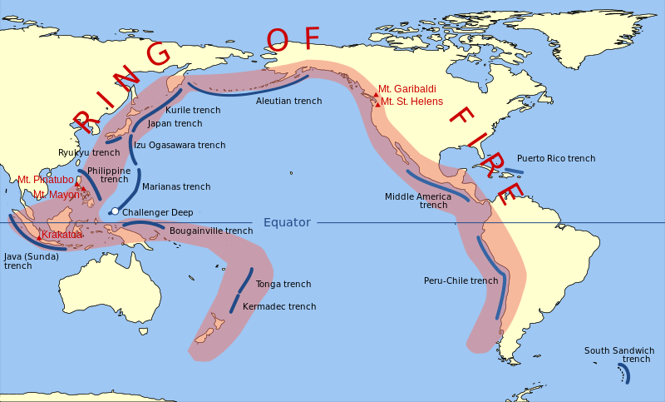
- At which type of plate boundary and at which other type of location are shield volcanoes found?

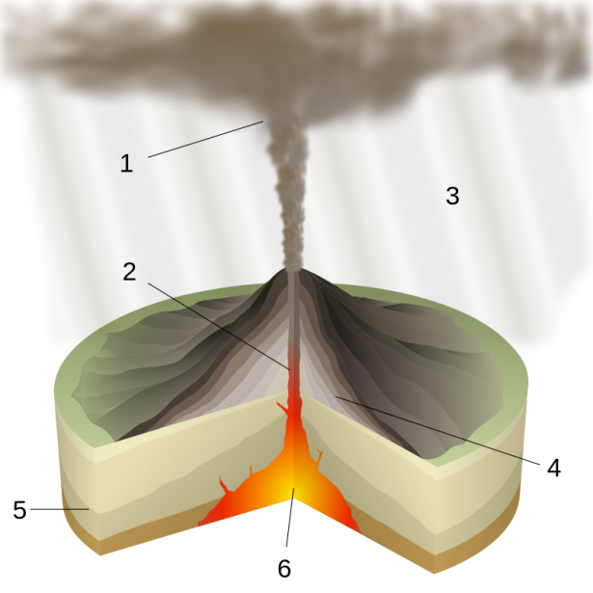
- What are the main features of the magma that makes up a shield volcano?

- Draw a labelled sketch of composite cone volcano.

- At which type of plate boundary are composite cone volcanoes found?

- What are the main features of the magma that makes up a composite cone volcano?

- Make a list of hazards found at volcanoes.

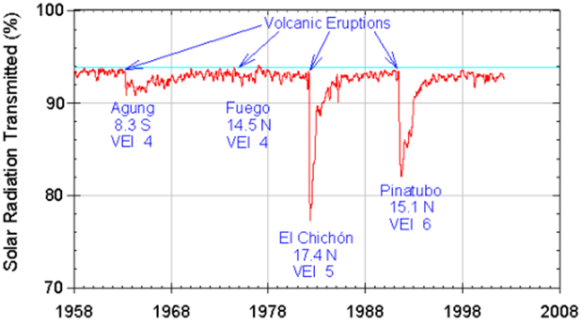
- What does the graph above tell you about how volcanoes can cause climate change?

- Draw up a table to show the differences and similarities between shield and composite cone volcanoes.

Similarities | Differences

- Where is the ‘Ring of Fire’?

- What is the ‘Ring of Fire’?
Decisions
- Put the section title Decisions and imagine that you are in charge of a town or city close to one of the volcanoes from article 2 such as Mount Vesuvius or Krakatau. 3 million people live in the danger zone of Vesuvius and over 20 million in the danger zone from Krakatau.

- Draw the following diagram and use it to help you to answer the question 25.a.
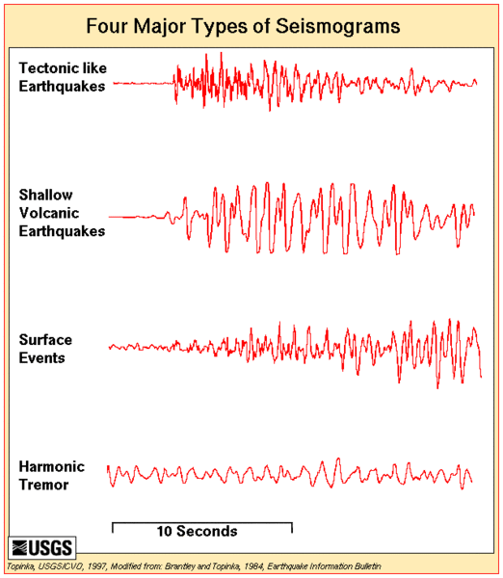
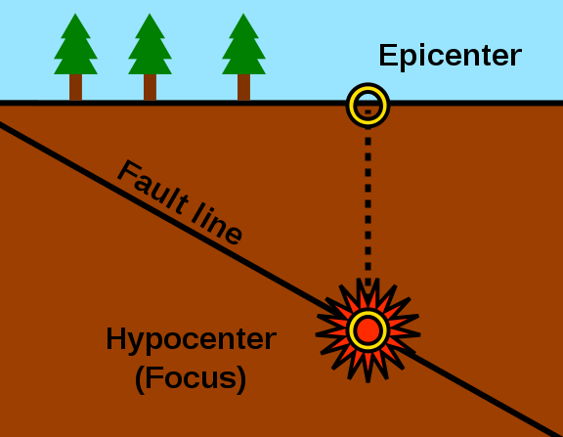
- Explain what a seismograph and explain:

  - How can P & S waves help to save lives if there is an earthquake?

  - How can a seismograph help to predict a volcano might be about to erupt?

- How could you use seismometers to help you to protect people living in your area?

- How else could you predict the volcano is about to erupt?

- How could modern information technology help you to help make people safer?

- Why is it important to make maps of where dangers and hazards are most likely?

- What is meant by ‘red lining’?

- Draw up a list under the heading ‘Prevention’. Write down as many items as you can on your list of the things that you would do to prevent a disaster when the volcano has a major eruption.

- Now draw up a ranked (most important first) list of planned drills for everyone to practice under the heading Preparation.

- Is evacuation the most important thing on your plan?
  - Justify why it is very important.
  - Describe and justify things might be above it.
  - Describe and justify things that might be below it.

