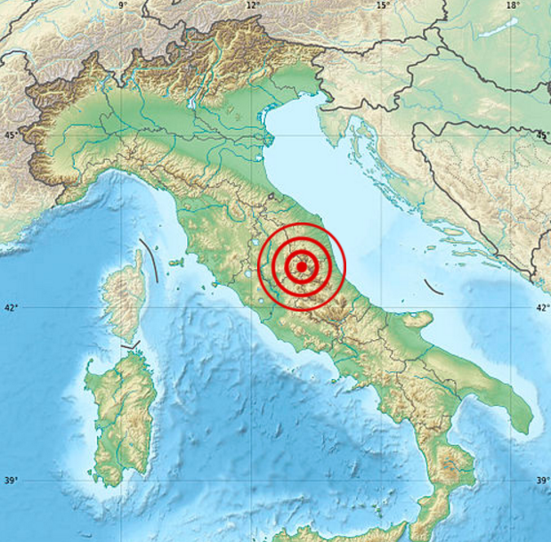
Introduction
- Put the section title Introduction.

- What are the five most important facts about the August 2016 Italy Earthquake.

- Cut out and use this map to describe the location of the earthquake.

- Draw a graph to show how many people were killed and the countries that they came from.
Nationality | Dead
Italy | 276
Romania | 11
United Kingdom | 3
United States | 1
Albania | 1
El Salvador | 1
Canada | 1
Spain | 1
Macedonia

- Cut out and use this map to describe the location of Italy within the belts of earthquakes around the Earth.

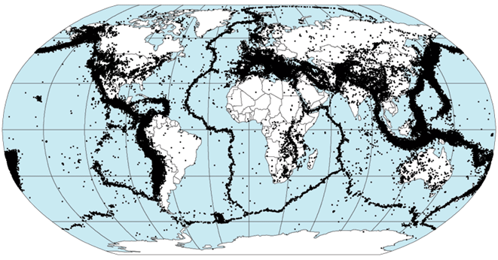

Background
- Put the section title Background.
- Put a sub-heading The Plate Tectonic Model.
- Cut out and use the following two maps to help you to describe the location of Italy relative to Tectonic Plates.

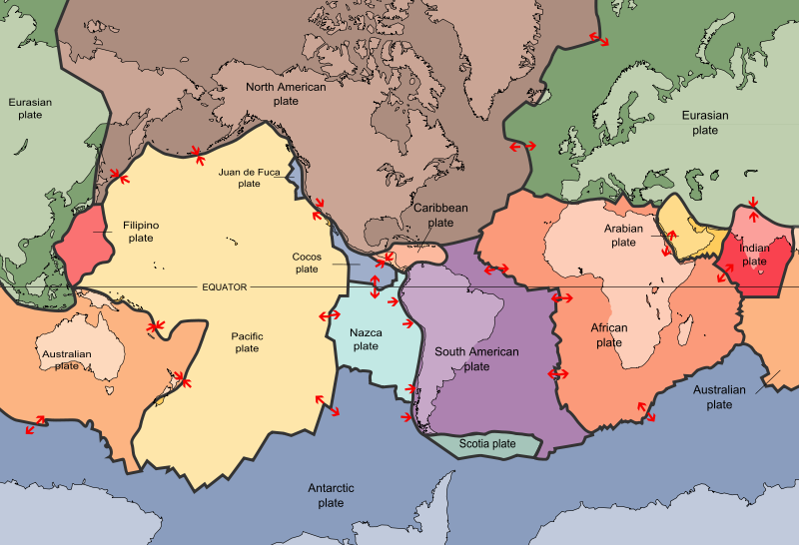

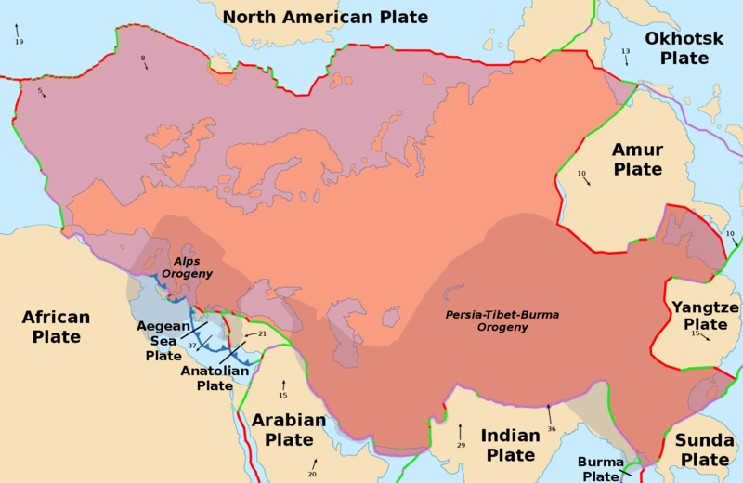

- Cut out and use the following diagram to help you describe the structure of the Earth.
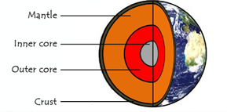

- Explain that the Tectonic Plates move on convection currents in the mantle.
- Cut out and use the following diagrams to explain the main types of plate boundaries:
Divergent Boundary
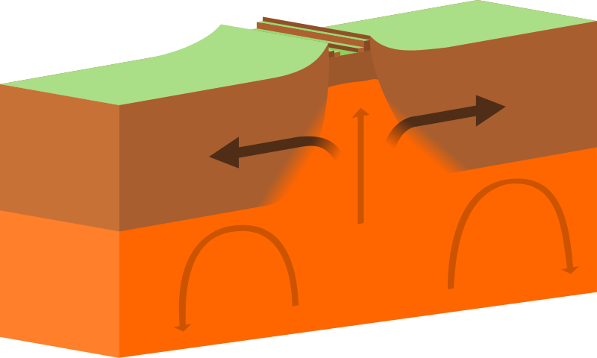

Convergent Boundary
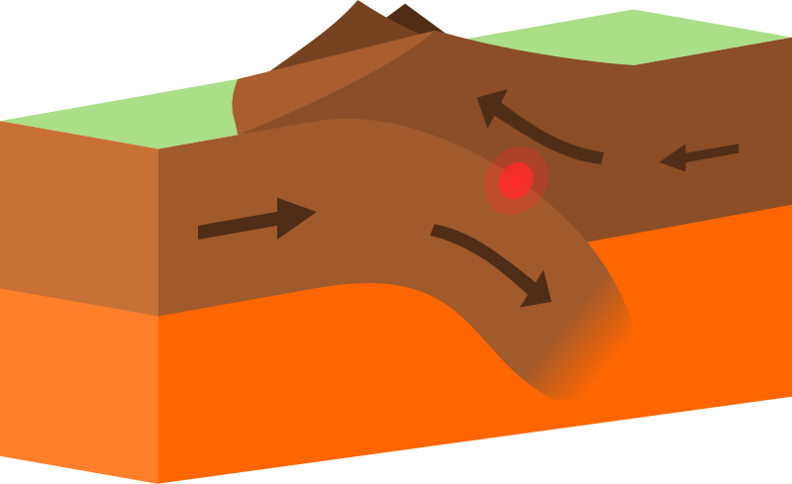
Conservative Boundary
