- Put the section title Introduction.

- What is the Welsh Government?

- What is the National Assembly for Wales?

- Since 2007 what is the role of:

- The Welsh Government?
- The National Assembly for Wales?

- What is an election?

- Who can vote in the May National Assembly election?

- What areas of power are devolved the National Assembly for Wales?

- Research each the six main parties taking part in the 2016 Assembly elections. Give a brief descriptions of main ideas of each:
  - Labour
  - Conservative
  - Plaid Cymru
  - Lib Dem
  - Greens
  - UKIP

- Put a subheading Questions for Enquiry.
- Devise some questions for enquiry use these but also add two of your own.
  - What patterns exist in Wales of where different parties have more seats?
  - Have these patterns changed since 1999?
  - Are there differences between my class and the constituency where I live?
  - ?
  - ?

- Put the section title Results.

- Draw up small table for each party with two columns – FOR and AGAINST.

For | Against

- Rank each of the parties in the order that you would vote for them.

- Carry Out a class mock election where everyone has a single vote to pick a first past the post party winner. Record your results in a table.
Party | Votes | %
Labour
Conservative
Plaid Cymru
Lib Dem
Green
UKIP

- Draw a bar graph to show your class results.

- Work out the percentages of votes cast for each party.

- Draw a pie chart based on the % values that you work out.

100 ÷ Total number of votes x Number of votes for each party

- Compare how your class compared to the 2011 results and then the 2016 results after the election.

2011 Election Results |  | Constituency Seats |  |  | Regional Seats |  |  |  | Total
Parties |  | Votes | Seats | Votes |  | % | Seats | Total |  | %
 | Labour | 401,677 | 28 | 349,935 |  | 36.9 | 2 | 30 |  | 50.0
 | Conservative | 237,388 | 6 | 213,773 |  | 22.5 | 8 | 14 |  | 23.3
 | Plaid Cymru | 182,907 | 5 | 169,799 |  | 17.9 | 6 | 11 |  | 18.3
 | Liberal Democrats | 100,259 | 1 | 76,349 |  | 8.0 | 4 | 5 |  | 8.3
 | UKIP | N/A | 0 | 43,756 |  | 4.6 | 0 | 0 |  | 0.0
 | Green Party | 1,514 | 0 | 32,649 |  | 3.4 | 0 | 0 |  | 0.0
 | Independent | 12,478 | 0 | 1,094 |  | 0.1 | 0 | 0 |  | 0.0

- For the elections in 1999, 2003, 2007 & 2011 draw graphs to show total number of seats for each party.

1999
Labour 28
Plaid 17
Conservative 9
Libs 6

2003
Labour 30
Plaid 12
Conservative 11
Libs 6
Independent 1

2007
Labour 26
Plaid 15
Conservative 12
Libs 6
Independent 1
2011
Labour 30
Plaid 11
Conservative 14
Libs 5

- Describe any changes you notice in your results graphs.

- Look at the different maps showing constituency seats in each election. Describe the pattern using the following prompts:

- What is the most popular party in North Wales?

- What is the most popular party in Mid and West Wales?

- What is the most popular party in South Wales Central?

- What is the most popular party in South Wales East?
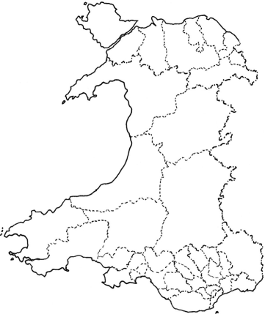
- What is the most popular party in South Wales West?

- Look at the maps of the results. Describe any pattern that you can see in where seats are changing.

- Use outline maps to show changes in regional seats during each elections. 1999 has been done for you in the online resource.

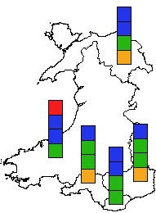

- For the actual 2016 election; draw a table to show the actual 2016 results.

Party | Votes
Labour
Conservative
Plaid Cymru
Lib Dem
Green
UKIP

- 2016 results draw a graph to show the actual 2016 results. Find these out after the election from a news website.

- Complete a map to show 2016 regional results.

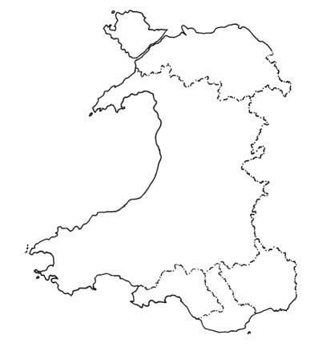

- Complete a map to show the 2016 constituency results.

- Give every map and graph a title and a number such as Map 1, Map 2, Graph, Graph2, Table 1, Table 2 until each one has a number.

- Put the section title Analysis.

- Put at least one piece of annotation on each map and graph. An annotation is a piece of writing on or near a diagram which is more detailed than a label.

- You are going to practice a skill called cross referencing. You are going to write some short paragraphs by referring to your maps and graphs. Such as:

In map 1 you can see……………..
Graph 3 shows that ……………………

- Use cross referencing to help you write a paragraph about where different parties get their most seats.

- Use cross referencing to help you write a paragraph about if there has been any changes in where a party wins its seats over time (1999 -2011 (and 2016).

- Use cross referencing to help you write a paragraph about if there is any difference between how you and your class votes compared to your constituency and also Wales as a whole.

- Put the section title Conclusions.
- In question 10 you devised some questions for enquiry; answer each question.
  - What patterns exist in Wales of where different parties have more seats?
  - Have these patterns changed since 1999?
  - Are there differences between my class and the constituency where I live?
  - ?
  - ?

- Put the section title Methodology.

- Describe how you obtained information from:
  - Primary sources such as carrying out a mock election or carrying out a survey (opinion poll)
  - Secondary sources (information collected by other people.

- For each type of map or graph that you produced say why you think it was a good choice to show the information.

- Put the section title Evaluation.

- Extension activities use data from a wider school mock election either first past the post by class or first past the post plus a second vote (regional vote) by year group:

  - Whole Year Group
  - Whole Key Stage
  - Whole School

