What Will We Do About Storms?
Decision Making Exercise

Imagine you have been appointed as a reporter for the BBC.

You will be asked to write a brief report for the Newsround programme outlining why storms in the UK are now being named and how the storms of winter 2015-2016 have been record breaking.

You will also need to give advice for younger people about what they should do to prepare for storms and floods.

- Give a background summary of why storms are being named by the Met Office.

- Describe and explain how storms affect people:
  - Wind
  - Precipitation

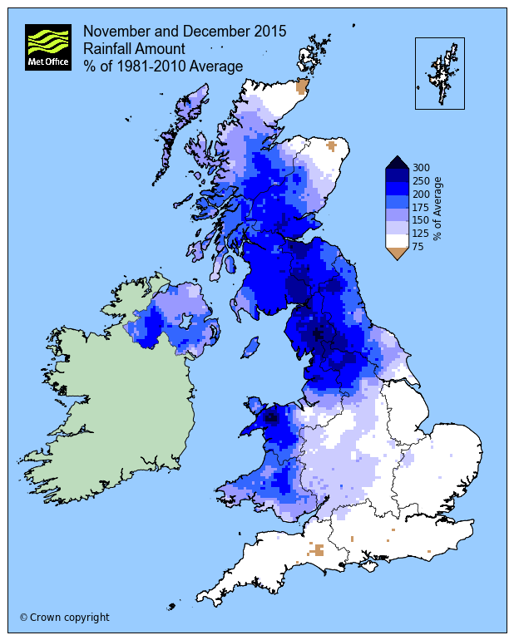
- Review data to describe how winter 2015-2016 has been a record breaking storm season.

  - Explain how Wales has been affected compared to the rest of the UK.

- Your Decision:
  - What should young people do before storms and floods
  - What should young people do after storms and floods
…………………………………………………..
- Use the Section heading Introduction before answering the following questions:
  - What is the Met Office?
  - Why are storms being named?
  - Is climate change affecting storms?
      - By how much?

- Try to find at least one weather record that has been broken during the 2015-2016 winter.

- Give a brief outline of the storms to affect the UK from November 2015 – February 2016; include:
  - Storm name
  - Areas most affected
  - Wind speeds
  - Power cuts
  - Loss of life
  - Estimated costs to fix

- Why might it be fair to say that Wales has been lucky with the storms that have hit the UK during winter 2015-2016?

- Draw a graph to represent the following information:
 | mm
Average Height of Man in UK | 1753
Average Height of UK boy aged six | 1170
48 Hour rainfall record Thirlmere, Cumbria 5/6th Dec. 2015 | 405
24 Hour rainfall record Honister Pass, Cumbria 5th Dec. 2015 | 341.4

- Complete these tasks from the online resource:
Map 1
- Overall what is it showing?
- Which places have the highest values (numbers)?
- Are any of the places with the highest values in Wales? Where?

Map 2
- Overall what is it showing?
- Which 3 places have the highest values (numbers)?
  - Where are they?
  - Where are they?

- Are any of the places with the highest values in Wales?
  - Where?
Graph 1
- Overall what is it showing?
- Which years have the highest values (numbers)?
- Which years have the lowest values (numbers)?
- Estimate (or work it out fully) a mean or average value.
- Roughly estimate how much bigger 2015 is compared to your estimate; choose from:
  - Times 1
  - Times 1.5
  - Times 2
  - Times 2.5
  - Times 3
  - Times 3.5
  - Times 4

Graph 2
- Overall what is the graph showing?
- Where is Shap?
- Where is Capel Curig?
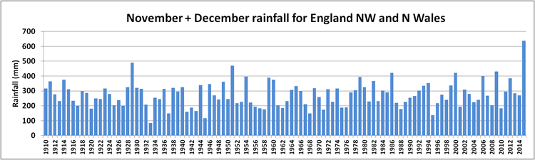
- Compare the rainfall for both locations in November and December.

- Has Northern England or Northern Wales had the most rain?
  - Which had the worst flooding?

- Most storms have been pushed North to the West of wales; why has this been important?

- Why has the direction of the storms been so important for Wales this winter?
  - Where have most of the storms travelled to/through?

- Check that your answers have covered all of the points (except the last one) in the big picture task from the start of this sheet.

Imagine you are a reporter for the BBC.
You are asked to write a brief report for the Newsround programme outlining why storms in the UK are now being named and how the storms of winter 2015-2016 have been record breaking.
You will also need to give advice for younger people about what they should do to prepare for storms and floods.
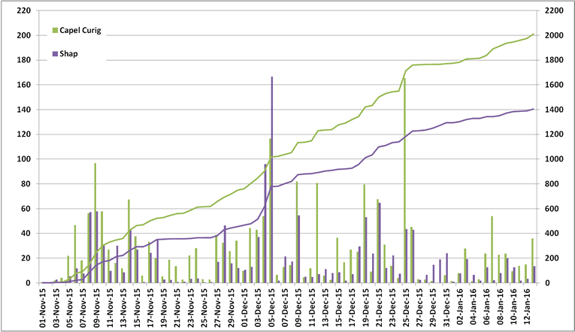
- Give a background summary of why storms are being named by the Met Office.

- Describe and explain how storms affect people:
  - Wind
  - Precipitation

- Look at and use the data to describe how winter 2015-2016 has been a record breaking storm season.

  - Say how and why Wales has been affected compared to the rest of the UK.

- Your Advice:
  - What should young people do before storms and floods
  - What should young people do after storms and floods

- Complete the last task in two paragraphs of your own composition:

Your Advice
  - What should young people do before storms and floods

  - What should young people do after storms and floods

