What Will We Do About Coastal Flooding?

Decision Making Exercise
Imagine you have been given a job in the Wales Coastal Monitoring Centre – W.C.M.C.

You will be asked to write a brief report about a part of the coast in Wales.

You will need to:

- Write some information about the coastal floods in 2013 and 2014.

- Use some of the information from the main article to say why floods might get worse along our coastlines.

- What do the following terms mean:
  - No Active Intervention (N.A.I.)
  - Hold the Line (H.T.L.)
  - Managed Realignment (M.R.)
  - Advance the Line (A.T.L.)

- Use maps to help you to show what has been planned for a place along our coastline in the following time periods:

  - Epoch 1 (short-term) = years 0 to 20.
  - Epoch 2 (medium term) = years 20 to 50 and.
  - Epoch 3 (long term) = years 50 to 100.

- Your Decision:
  - Either justify why you think this is the best option or
  - Provide an alternative plan and justify why you have changed it.

- Extension
  - Choose more locations to explore different options of managing our coast against future floods.
…………………………………………………..
- Use the section heading Introduction before answering the following questions in the form of a paragraph (not separately):

  - What is coastal flooding?
  - What happened in December 2013?
  - What happened in January 2014?

- Use this quote to help you explain what scientists think might happen in the future.

“Projections for the future of our coastal areas are of increasing risk, as a consequence of climate change and in particular sea level rise.”

- Use this quote to help you explain what the IPCC said in 2014 about temperature change and sea level change.

“Global temperatures have risen 0.85°C from 1880-2012. There has been an associated rise in global sea level which is now increasing at approximately 3.2 mm per year. The IPCC state that it is very likely that the 21st Century sea level rise rate will exceed the 1971-2000 rate, for all modelled emissions scenarios. “
- Use this quote to help you explain how an expected sea level increase of 0.5 metres would affect how frequent sever sea level events would be.

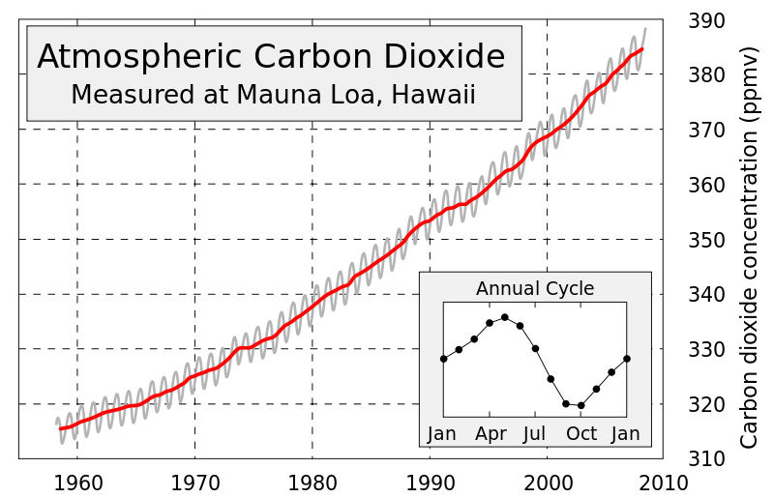
“An increase of 0.5m is estimated to result in 10-fold to 100-fold increase in the frequency of sea level extremes (relative to present day) in northern Europe by the end of the century. This would mean a coastal flooding event that has a return period of 100 years at present will potentially occur on average between every year and every ten years by 2100.”

- Describe what this graph is showing you by answering these questions:

  - What was the Carbon Dioxide in 1960?
  - What was the Carbon Dioxide in 2008?
  - By how much has the Carbon Dioxide level changed?

- How might Carbon Dioxide cause coastal flooding?

- Are there any other reasons that coastal flooding might get worse in the future?

- Write down the section heading Options.

- Explain the meaning of the following options:

  - No Active Intervention (N.A.I.)
  - Hold the Line (H.T.L.)
  - Managed Realignment (M.R.)
  - Advance the Line (A.T.L.)

- Using a map to help you; show what has been planned for a particular section of coastline for each of the three time periods:

  - Epoch 1 (short-term) = years 0 to 20.
  - Epoch 2 (medium term) = years 20 to 50 and.
  - Epoch 3 (long term) = years 50 to 100.

- Put the section heading Decision.

- Write down your decision, either:

  - Either justify why you think this is the best option or
  - Provide an alternative plan and justify why you have changed it.

- Write down the section heading extension.

- Look at recommendations for other sections of the coastline that you do not agree with and provide alternatives and justify them.

