The 2nd of April 2012 marks the 30th anniversary of the start of the Falklands War.
The Falkland Islands are in the south Atlantic, 12,700 Km from the UK and about 700 km from South America and the country of Argentina. They became formally part of the British empire in1843 but in1960 the United Nations called for an end to colonies worldwide and the UK listed the Falklands as one of its colonies. This began Argentina’s claims of ownership.
In 1982 the Argentinean military invaded the islands and there was a short but violent series of battles called the Falklands War, ending with British troops taking over the island. In 1995 the British and Argentine governments sign a Joint Declaration saying there should be a Special Area of Cooperation for the exploration and exploitation of offshore minerals and oil under the seas around the Falklands.

Now in 2012 relationships between Argentina and the UK have got worse again. Argentina has objected to a British nuclear submarine to the region. They see the presence of helicopter pilot Prince William , a visit from members of parliament and the expected arrival of a modern UK warship, HMS Dauntless, as a military threat.

So what is all the fuss about?
1/ There are just over 3000 British people living on the Falklands. The UK government has said it will not consider transferring the islands to Argentinean rule if the islanders do not wish it.
Argentina argues that the islanders do not have the right to make that decision, because they arrived to replace the Argentine population in 1833.
2/ Argentina claims ownership of the shallow sea (continental shelf), under a 1958 UN Convention on Continental Shelves. The UK disputes this.
3/ The areas around Falkland Islands are said to have one of the world's largest reserves of oil, Discovered in 1998, the British Geological Survey estimates the oil at about 60 billion barrels!! In short, whoever owns the Falklands has access to a huge energy source and will be very rich in the future!
Where is the most energetic island in the UK? - Anglesey of course!
Even before the rise of renewable energy development, Anglesey was the home of Wylfa nuclear power station. It began producing electricity in 1971 and was the last of its type to be built in the UK. It will stop production permanently this year (2012) , but the owners will have to wait till after 2025 before it will be safe to dismantle the buildings. Final site clearance will be in 2091when the last of the radioactivity will be low enough to manage !
Anglesey’s energy potential is much more than that. It is surrounded by sea with very powerful tidal currents as water rushes in and out of Liverpool Bay through the Menai straights or round Holyhead Island to the west. These flows change direction every 6 ¼ hours and can move at up to 10km hour all powered by the gravity of the moon.
Large waves carry Atlantic storm energy onto Anglesey’s western shores and the island’s relatively low flat ground next to the sea give access to higher than average windspeeds. It is even sometimes sunny enough to provide solar power. !
The Anglesey Energy Island initiative was launched in 2010 and is linked with education and research at Coleg Menai, Llangefni in the centre of Anglesey. Energy from wind, tidal, biomass, and other micro-generation projects as well as the potential of a new nuclear build at Wylfa, are being explored.
In 2011 the island became one of the Wales Enterprise zones with the focus on energy schemes.

Welcome to your friendly local Power-stations in rural Wales!
Government subsidies for micro-electricity generation have changed the appearance of some housing in many Welsh villages. Solar power micro- generation schemes have been fitted to many Welsh roofs and each contributes a valuable trickle of electricity back into the Country’s electricity grid.
Solar panels will produce electricity in daylight, including cloudy or cold days, as it is the solar radiation, not the air temperature that provides the energy.
The local geography is really important in deciding how efficient a solar panel will be.
- The panel should face south. The sun rises in the east and sets in the west and will be at its maximum power at mid-day when the angle of light passing through the atmosphere is at its steepest. This means there will be the least amount of energy filtered out during its passage through the air and dust in our atmosphere. As a result, people who have fitted systems on roofs facing west or east cannot collect as much energy.
- The panels must not have shade on any part of them as the efficiency of the whole set will drop when 1 out of the set has reduced light. This means a tree in the way will affect the whole production and shadow from a hill or another house will cause a big reduction.
- Ideally the angle of the roof should be at right angles to the sun’s rays so that the rays that fall on them are as concentrated as possible.
- A typical set of set of 5 panels with current technology will produce about 1000 watts of electricity, midday in a sunny summer. This is enough to power lights and a big TV but less than half needed to boil a typical kettle. However it produces electricity all the time and kettles boil in a few minutes so some export into the national grid is almost guaranteed!
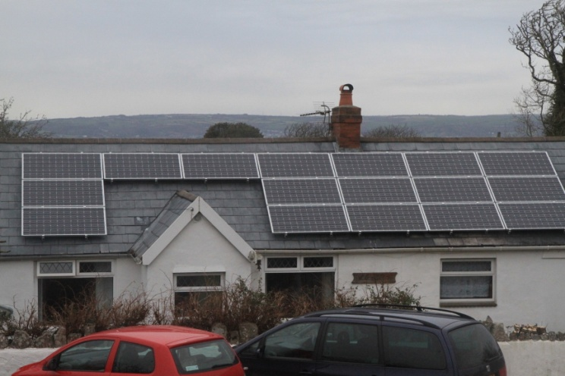

Image: Courtesy of Andy Freem

